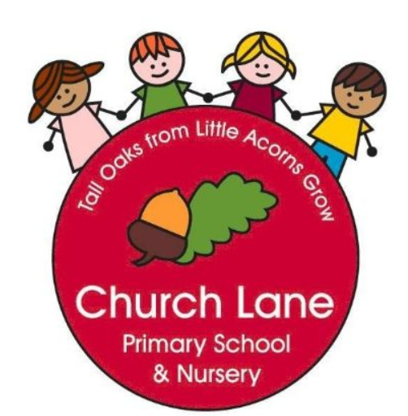 **EYFS Curriculum: Personal, Social and Emotional Development**

**Our Educational Programme:**

At Church Lane Primary School and Nursery we strongly believe that PSED is crucial for children to be healthy, happy and feel supported in their world. Developing children’s personal, social and emotional development is a huge priority during every minute of our day across EYFS. We will support children through our daily interactions, circle times when matters arise and on a 1:1 level. We use puppets, books and songs to help us talk about our emotions and approach with empathy and in a supportive manner. Supporting our families is also key to our curriculum; parent partnership is at the heart of what we do.

In addition to our daily interactions that support PSED, Jigsaw Jenie plays a big part in our curriculum. Across EYFS we ensure dedicated time each week is given to developing PSED. The children love talking to Jigsaw Jenie, cuddling and sharing worries with her; the children are always sad to say goodbye when they move to Year 1 but equally excited to meet Jigsaw Jack!

Developing an understanding of oral health is key to our curriculum offering and is now part of our Life Skills Curriculum. We work with dentists and parents to promote good oral health across EYFS.

Below is our ambitious curriculum which shows progression across EYFS through the teaching of a variety skills and knowledge, including rich vocabulary. As our children move through the EYFS, the curriculum is designed to ensure all children develop the desired building blocks to ensure they have all the skills and knowledge needed to access National Curriculum. We will use the planned knowledge and skills as a guide (not rigid and not an exhaustive list) throughout the year and will adapt accordingly depending on cohort needs, interests and any gaps in learning.

**Communication and Language is at the heart of our curriculum**

**Progression document**

**National Curriculum links: PSHE**

|  |  |  |
| --- | --- | --- |
|  | **Nursery** | **Reception** |
| **Autumn 1**  **Being in my world** | I understand how it feels to belong and that we are similar and different  I understand how feeling happy and sad can be expressed  I can work together and consider other people’s feelings  I can use gentle hands and understand that it is good to be kind to people  I am starting to understand children’s rights and this means we should all be allowed to learn and play  I am learning what being responsible means | I understand how it feels to belong and that we are all similar and different  I can start to recognise and manage my feelings  I enjoy working with others to make school a good place to be  I understand why it is good to be kind and use gentle hands  I am starting to understand children’s rights and this means we should all be allowed to learn and play  I am learning what being responsible means |
| **Autumn 2**  **Celebrating difference** | I know how it feels to be proud of something I am good at.  I can tell you one way I am special and unique.  I know that all families are different.  I know there are lots of different houses and homes.  I can tell you how I could make new friends.  I can use my words to stand up for myself. | I can identify something I am good and understand everyone is good at different things  I understand that being different makes us special  I know we are all different but the same in some ways  I can tell you why I think my home is special to me  I can tell you how to be a kind friend  I know which words to use to stand up for myself when someone says or does something unkind |
| **Spring 1**  **Dreams and Goals** | I understand what a challenge means  I can keep trying until I can do something  I can set a goal and work towards it  I know some kind words which can encourage people  I can start to think about the jobs I might like to do when I’m older  I can feel proud when I achieve a goal    Focus: Brushing teeth at home | I understand that if I persevere I can tackle challenges  I can tell you about a time I didn’t give up until I achieved my goal  I can set a goal and work towards it  I can use kind words to encourage people  I understand the link between what I learn now and the job I might like to do when I’m older  I can say how I feel when I achieve a goal and know what it means to feel proud      Focus: Brushing teeth at home |
| **Spring 2**  **Healthy me** | I know the names for some parts of my body and am starting to understand that I need to be active to be healthy  I can tell you some of the things I need to do to be healthy  I know what the word ‘healthy’ means and that some foods are heathier than others  I know how to help myself go to sleep and that sleep is good for me  I can wash my hands and know it is important to do this before I eat and after I go to the toilet  I know what to do if I get lost and how to say NO to strangers    Focus: Going to the dentist | I understand that I need to exercise to keep my body healthy  I understand how moving and resting are good for my body  I know which foods are healthy and not so healthy and can make healthy choices  I know how to help myself to go to sleep and understand why sleep is good for me  I can wash my hands thoroughly and understand why this is important especially before I eat and after I go to the toilet  I know what a stranger is and how to stay safe if a stranger approaches me    Focus: Going to the dentist |
| **Summer 1**  **Relationships** | I can tell you about my family  I understand how to make friends if I feel lonely  I can tell you some of the things I like about my friends  I know what to say and do if somebody is mean to me  I can use Calm Me time to manage my feelings  I can work together and enjoy being with my friend    Focus: Dummies and bottles | I can identify some of the jobs I do in my family and how I feel like I belong  I know how to make friends to stop myself from feeling lonely  I can think of ways to solve problems and stay friends  I am starting to understand the impact of unkind words  I can use Calm Me time to manage my feelings  I know how to be a good friend    Focus: Dummies and bottles |
| **Summer 2**  **Changing me** | I can name parts of my body and show respect for myself  I can tell you some things I can do and some food I can eat to be healthy  I understand that we all start as babies and grow into children and then adults  I know that I grow and change  I can talk about how I feel moving to School from Nursery  I can remember some fun things about Nursery this year    Focus: Healthy choices | I can name parts of the body  I can tell you some things I can do and foods I can eat to be healthy  I understand that we all grow from babies to adults  I can express how I feel about moving to Year 1  I can talk about my worries and/or the things I am looking forward to about being in Year 1  I can share my memories of the best bits of this year in Reception    Focus: Healthy choices |

Assessment tracker:

