

Early Years Foundation Stage (EYFS) Policy

Intent

At Church Lane Primary School and Nursery we offer a tailor made curriculum that supports the 7 Areas of Learning stated in the ‘Statutory framework for the early years foundation stage.’ We do this by starting from the child- what do they already know? What do they want to discover? Where do they need to go next?

Our overall aim is to ensure every child progresses through each area of learning at their own pace, building on their next steps to ensure they achieve their Early Learning Goals and to be ready for Year 1.

The Prime Areas:
- Personal, Social and Emotional Development
- Communication and Language
- Physical Development
The Specific Areas:
- Literacy
- Maths
- Understanding of the World
- Expressive Arts and Design
To ensure our children become competent and confident learners and achieve their full potential we will offer an ambitious, broad and language-rich curriculum. Our curriculum will have a blended approach where ‘in the moment planning’ (tailored to interests and next steps) runs alongside our planned curriculum (what we want our children to learn to succeed). Our curriculum is designed to ensure children “know more and remember more.” We revisit and practise previous learning to ensure learning is remembered throughout EYFS.


ITMP
Skilled practitioners & engaging learning environments
Planned
Curriculum
Books/poems/rhymes

Our highly skilled staff will also:

- Provide a playful learning environment that provides the balance of adult led and child-initiated activities through the interests of individual children. We strongly believe that opportunities for interest-based learning accelerates progress due to high levels of engagement.
- Provide a carefully planned curriculum that does not put a ceiling on children’s learning.
- Offer real life experiences that build cultural capital (what children already know).
- Provide a progressive curriculum that also focuses on key life skills.
- Develop a well-rounded child by ensuring all areas of learning have an equal importance.
- Ensure building blocks are in place so every child is ready for their next step of their journey e.g. Nursery to Reception and Reception to Year 1.
- Targeted support for children with SEND, Pupil Premium and EAL.
- Provide a language rich environment through our love for story books, poems and songs. This is paramount to ensure children foster a love of life-long reading and knowledge is supported through the books we read.
- Areas of Learning will be underpinned with a variety of carefully chosen story books.
- Ponder, wonder, question, challenge, facilitate are just a few teaching strategies that will be used across EYFS. These interactions will ensure children are stretched and moved on in their learning.
- Ensure the ‘Characteristics of Effective Teaching and Learning’ are fully embedded through our engaging, open-ended and creative learning environments.
- Encourage children to set their own goals
- Promote our school values through our daily routines.
- Have access to high quality CPD across the year.
- Our pedagogy is underpinned by current research.
- Our aim is for all children to ‘know more and remember more.’

“Teaching should not be taken to imply a ‘top down’ or formal way of working. It is a broad term that covers the many different ways in which adults help young children learn. It includes their interactions with children during planned and child-initiated play and activities: communicating and modelling language, showing, explaining, demonstrating, exploring ideas, encouraging, questioning, recalling, providing a narrative for what they are doing, facilitating and setting challenges. It takes account of the equipment adults provide and the attention given to the physical environment, as well as the structure and routines of the day that establish expectations.”
-OFSTED

Implementation

We will implement our curriculum by offering a rich and active approach to learning underpinned by the Characteristics of Effective Teaching and Learning. During our continuous provision time we will work on next steps and target the children who need additional support to ensure we close the gaps in learning.

Three Characteristics of Effective Learning

Playing and Exploring – do they investigate and experience things and ‘have a go’?

Learning Actively – do they concentrate and keep on trying if they encounter difficulties and enjoy achievements?

Creating and Thinking Critically – do they have and develop their own ideas, make links between ideas and develop strategies for doing things.

Our role is to ensure teaching and learning takes place through a wide range of interactive processes. Teaching and learning opportunities will occur across the whole pedagogical continuum- EEF

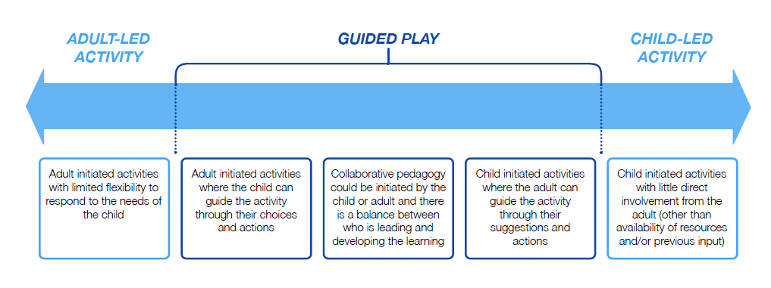

The cycle below shows how we implement our ambitious curriculum:

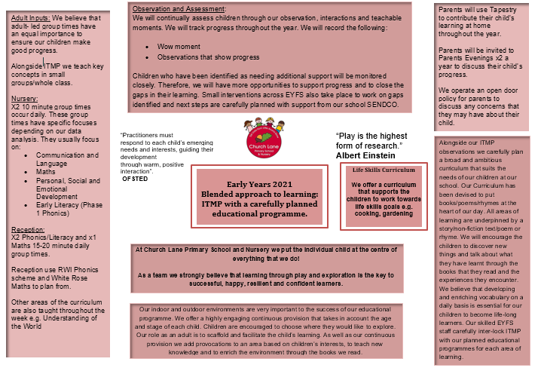

The Early Years Foundation Stage (EYFS) applies to children from birth to the end of the Reception year.

The EYFS is based upon four principles:

- A unique child – developing resilient, capable, confident and self-assured individuals
- Positive relationships – supporting the children in becoming strong and independent
- Enabling environments with teaching and support from adults – who respond to their individual interests and needs to help them to build their learning over time and children benefit from developing a strong partnership between practitioners, parents/carers and the child
- Learning and developing – an acknowledgement that children learn in different ways and at different rates

A Unique Child

We recognise that every child is a competent learner who can be resilient, capable, confident and self-assured. We recognise that children develop in individual ways, at varying rates. Children’s attitudes and dispositions to learning are influenced by feedback from others; we use praise and encouragement, as well as celebration/ sharing assemblies and rewards, to encourage children to develop a positive attitude to learning.

Inclusion/Special Educational Needs (SEN)

All children and their families are valued at Church Lane Primary School and Nursery. Children are treated as individuals and have equal access to all provisions available. All children are encouraged to achieve their personal best and planning is adapted to meet the needs of all groups and abilities. Assessments take into account contributions from a range of perspectives to ensure that any child with potential special educational needs is identified at the earliest possible opportunity. Early identification of special needs is crucial to enable staff to support the development of each child. Concerns are always discussed with parents/carers at an early stage and the schools SENCO is called upon for further information and advice. Appropriate steps are taken in accordance with the school’s Inclusion policy for SEN.

We meet the needs of all our children through:

- Planning opportunities that build upon and extend children’s knowledge, experience and interests, and develop their self-esteem and confidence.
- Using a wide range of teaching strategies based on children’s learning needs.
- Providing a wide range of opportunities to motivate and support children and to help them to learn effectively.
- Providing a safe and supportive learning environment in which the contribution of all children is valued.
- Using resources which reflect diversity and are free from discrimination and stereotyping.
- Monitoring children’s progress and taking action to provide support as necessary e.g. setting achievable targets

Atlas room
From September 2023 we have extra provision dedicated to supporting children who have additional needs. Children in Reception who may need some time to regulate or need further targeted work have access to our specialist provision. The Atlas room has a dedicated teacher and two Teaching Assistants who offer this unique support.

Welfare

It is important to us that all children are ‘safe’. We aim to support all children to develop and understanding of boundaries, rules and limits and to help them understand why they exist. We provide children with choices to help them develop this important life skill. Children should be allowed to take risks but need to be taught how to recognise and avoid hazards. We aim to protect the physical and psychological well being of all children.

At Church Lane Primary School and Nursery we understand that we are legally required to comply with certain welfare requirements as stated in the Statutory Framework for Early Years Foundation Stage 2023. We understand that we are required to:

- Promote the welfare and safeguarding of children including oral health.
- Promote good health, preventing the spread of infection and taking appropriate action when children are ill.
- Manage behaviour effectively in a manner appropriate for the children’s stage of development and individual needs.
- Ensure all adults who look after the children or who have unsupervised access to them are suitable to do so.
- Ensure that the premises, furniture and equipment is safe and suitable for purpose.
- Ensure that every child receives enjoyable and challenging learning and development experiences tailored to meet their needs.
- Maintain records, policies and procedures required for safe efficient management of the setting and to meet the needs of the children.

Positive Relationships

We recognise that children learn to be strong and independent from secure relationships. We aim to develop caring, respectful, professional relationships with the children and their families. In order to achieve this we operate a ‘Key Person’ system. We also use Tapestry across EYFS to encourage home-school communications.

Parents as Partners

We recognise that parents are children’s first and most enduring educators and we value the contribution they make. We recognise the role that parents have played, and their future role, in educating the children. We do this through:
- New Nursery children are encouraged to do ‘taster’ sessions with parents before they start.
- Involving parents in their child’s ‘learning journey’ inviting them to contribute their own observations of their child’s progress using Tapestry.
- Daily communication with parents regarding their child’s day and their achievements
- Support children and parents through the transitions they make from Nursery into Reception and into Year 1
- Inviting parents to parent’s evenings where their child’s progress can be discussed and any concerns identified.
- Arranging a range of activities throughout the year that encourage collaboration between child, school and parents.
- Ensuring all parents know who their child’s key person is and that their key person is available to talk to when they arrive with their child or on collection at the end of the session.
- Learning workshops will be delivered throughout the year to ensure home-school partnership .
- Tapestry will be used to encouraged parent-staff-child relationships.

Enabling Environments with teaching and support from adults

We aim to create an attractive and stimulating learning environment where children feel confident, secure and challenged. The children have daily access to an indoor and outdoor environment that is set up in discrete areas of learning with planned continuous provision.

We offer a highly engaging continuous provision that takes in account the age and stage of each child. Children are encouraged to choose where they would like to explore. Our role is to scaffold and facilitate the child’s learning. We also add provocations to an area based on interests, curriculum focus and to add challenge or to stimulate an unused area. Children are also expected to take part in a ‘Rainbow Challenge’ that tests their knowledge of what has been taught in previous weeks.

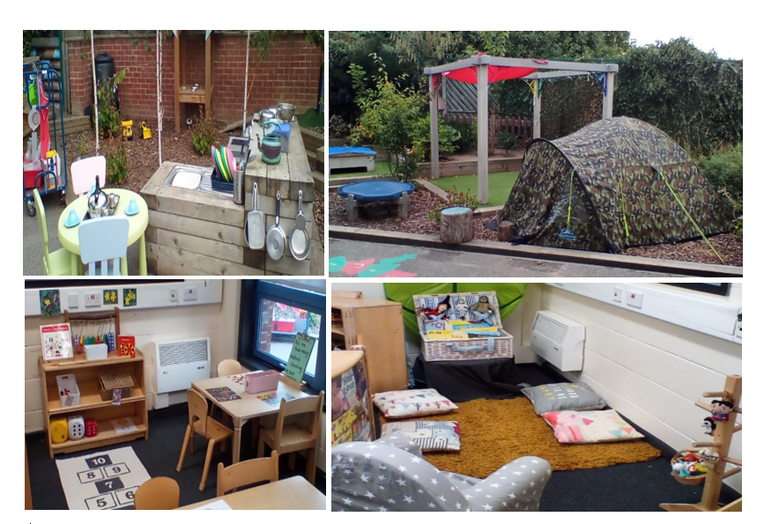

Learning and Development

At Church Lane Primary School and Nursery we put the individual child at the centre of everything we do and believe that every child can succeed. We continuously observe each child to identify emerging needs. We will only record ‘observations’ that are meaningful for that child and family with a particular focus on celebrating progress. We value our time spent with each child and believe that our time should be talking, interacting and engaging with each child; not recording every interaction.

Adult guided group times are in place in Nursery and Reception each having different focuses. The balance will shift towards a more equal focus on all areas of learning as children grow in confidence and ability within the three prime areas. However, if a child’s progress in any prime area gives cause for concern, staff will discuss this with the child’s parents and/or carers and agree how to support the child. This may also include a discussion with the SENCO to access Special Educational Needs support.

In Nursery promoting Communication and Language skills is fundamental to everything we do. We also promote pre-phonics (early reading skills). Focusing on the foundations to early reading is fundamental to giving all children the key skills to develop into confident readers and writers in the future.

In Reception we move onto the RWI Phonic scheme, which is in line with the rest of the school. We also plan our Maths through White Rose and Mastering Number. We strongly believe that mastery in Maths begins in the Early Years and that all children can achieve. We are committed to providing a range of opportunities that develop depth to sustain progress over time.

We offer a broad and ambitious curriculum that carefully guides the children to develop and deepen knowledge throughout the EYFS.

Assessment
We have four key assessment points across the year; Baseline (on-entry), October, January, April and June/July. We use a traffic light system which indicates whether a child is on track or not. We use our professional judgement and OPAL milestones to ensure our judgements are consistent across EYFS.

Key

High area of concern

Moderate area of concern

No area of concern

We then use this information to plan how we are going to support children who are ‘red’. We work with parents, SENDCo and outside agencies to put a plan in place and to set achievable targets. This then feeds into our daily intervention plan where we monitor progress and support the child to meet their individual targets.

We use our professional judgement when assessing and have regular team meetings about each child. We also moderate with other schools in the area to ensure judgements are consistent and accurate.

Equal Opportunities

All members of the school and nursery are treated as individuals. We aim to meet the needs of all, taking account of gender, ability, ethnicity, culture, religion, language, sexual orientation, age, special educational needs, disability, and social circumstances. All staff are aware of the need for the curriculum to reflect cultural diversity and the need to prepare pupils for life in a diverse and multi-faith society. We follow the Lincolnshire agreed syllabus for Religious Education 2018 across Early Years to ensure we cover the statutory requirement for Reception. British Values and Protected Characteristics are encouraged throughout EYFS.

Health and Safety

At Church Lane Primary School and Nursery there are clear procedures for assessing risk (see whole school risk assessment policy and individual Early Years risk assessments), which includes procedures for keeping children safe during outings and for any aspects of the environment, or provision that may require a further risk assessment.

In line with the EYFS statutory framework 2024, we undertake;

- A medication policy ensuring that there are systems in place to ensure that medicines and the systems for obtaining information about a child’s needs for medication are kept up to date. Medicines will not be administered unless they have been prescribed by a doctor, dentist, nurse or pharmacist. Training is provided for staff where the administration of medicine requires medical or technical knowledge. Medicines (both prescription and non-prescription) are only administered to a child where written permission for that particular medicine has been obtained from the child’s parent and/or carer. Level 3 qualified staff only are permitted to administer medications.
- Fresh drinking water is available at all times
- Children’s’ dietary needs are recorded and acted upon when required

- A first aid box is accessible at all times and a record of accidents and injuries are kept (see accident and injury policy).
- A health and safety policy and procedure, which covers identifying, reporting and dealing with accidents, hazards and faulty equipment
- A fire and emergency evacuation procedure and policy
- A safeguarding policy stating how mobile phones and cameras are to be used and stored securely whilst children are in the setting. Cameras that are used in school must not be used for staff own personal use.
- Appropriate clothing, in particular in relation to the wearing of sensible flat shoes and nursery uniform. Staff are expected to wear clothing that supports them in getting to a child’s level and playing and engaging with children at floor level.

Updated September 2024
Review Date September 2025
Updated by Kelly Hakes (EYFS Lead)

