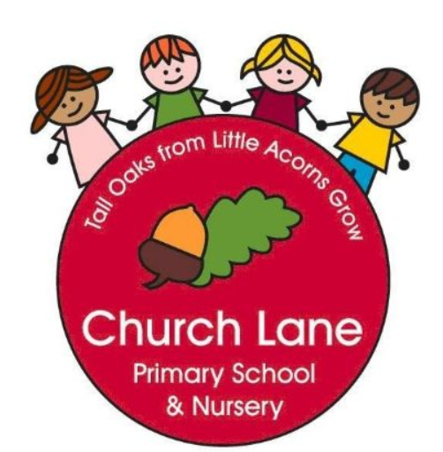 **EYFS Curriculum: Maths**

**What does this look like across EYFS?**

**Our Educational Programme:**

At Church Lane Primary School and Nursery we strongly believe in paving the way to ensure strong foundations are made throughout EYFS. We have a progressive curriculum which ensures all children have time to consolidate their mathematical learning and develop a deep understanding of numbers to 10. Across EYFS we use White Rose Maths. Maths is seen everywhere inside and outside our provision, including snack time. We promote a ‘have a go’ attitude to Maths, supporting every child to feel confident to reason and explore all areas of Maths.

Below is our ambitious curriculum which shows progression across EYFS through the teaching of a variety skills and knowledge, including rich vocabulary. As our children move through the EYFS, the curriculum is designed to ensure all children develop the desired building blocks to ensure they have all the skills and knowledge needed to access National Curriculum. We will use the planned knowledge and skills as a guide (not rigid and not an exhaustive list) throughout the year and will adapt accordingly depending on cohort needs, interests and any gaps in learning.

**Communication and Language is at the heart of the curriculum.**

Below is our ambitious curriculum which shows progression across EYFS through the teaching of a variety skills and knowledge, including rich vocabulary. As our children move through the EYFS, the curriculum is designed to ensure all children develop the desired building blocks to ensure they have all the skills and knowledge needed to access National Curriculum. We will use the planned knowledge and skills as a guide (not rigid and not an exhaustive list) throughout the year and will adapt accordingly depending on cohort needs, interests and any gaps in learning.

**Communication and Language is at the heart of the curriculum.**

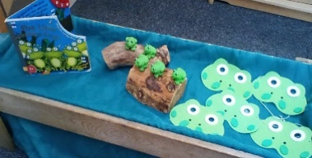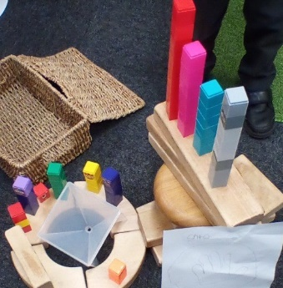

**Progression document**

**National Curriculum links: Maths**

|  |  |  |  |  |  |
| --- | --- | --- | --- | --- | --- |
|  | **Nursery** | **Key books** | **Reception** | **Key Vocabulary** | **Key books** |
| **Autumn** | **Block 1- More than, fewer than, same**    **Block 2- Explore and build with objects and shapes**    **Block 3- Explore repeats**    **Block 4- Hear and say number names**    **Block 5- Begin to order number names**    **Block 6- I see 1,2,3**    **Block 7- Join in with repeats**    **Block 8- Explore position and space** | Harry and the Bucketful of Dinosaurs  Little Red Riding Hood  Whatever Next  Little Red Hen  Peepo!  Each Peach Pear Plum  The Three Billy Goats Gruff  The Three Little Pigs  Goldilocks and the Three Bears  Brown Bear, Brown Bear, What Do You See? | **Baseline Assessments for the first 2 weeks**  **Block 2- Talk about measure and pattern**      **Block 4- Circles and Triangles**    **Block 6- Shapes with 4 sides**    **Number**  Match and Sort  Compare amounts  Subitise 1, 2, 3.  Make and describe spatial patterns with 3 dots.  Represent quantities in different ways using fingers.  Match and sort objects.  Recognise that counting is useful because it tells us ‘how many.’  Recognise that the last number in the count tells us ‘how many altogether.’  Recognise that 2 is made of 1 and ‘another 1.’  Identify when a collection is composed of 3 objects.  Identify when a collection is composed of 3 or not 3.  Use positional language to describe patterns of 4.  Compare 2 sets of objects and say which is ‘more than’ or ‘fewer than.’  **Representing 1-5**  Collect five objects and show 5 using hand template.  Say and make numbers to 5.  Use a die frame to represent 5  Count 5 and 5 to make 10 altogether  Match different representations of quantities to 5 with fingers.  Represent quantities in more abstract way e.g. clapping/jumping  Recognise numerals to 5  Understand that when a set of objects is  **Comparing 1-5**  Recognise ‘more than’ or ‘fewer than’ by looking.  Recognise when there is an equal number.  Recognise when there is an equal number, too many or nor enough.  Build and match towers with an equal number of squares.  **Composition of 1-5**  Identify whole and part of a familiar object.  Identify parts of own body.  Recognise that some whole objects have parts that cannot be removed.  Know that 1 and 2 are parts of 3.  Explore how 1 and 2 are parts of 3.  Investigate ways to compose and de-compose 4 and 5. | Compare  Numeral  Subitise  Match  Pairs  Sort  Odd one out  Large/small  Few/fewest  More/most  Small/large  Tall/thin  Pattern/repeating pattern  Count | A Pair of Socks  Seaweed Soup  The Button Box  Beep Beep, Vroom Vroom!  Where’s my Teddy?  It’s the Bear!  The Blue Balloon  Dear Zoo  Were Going on A Bear Hunt  My First Book of Patterns  Anno’s Counting Book  Goldilocks and the Three Bears  The Gingerbread Man  A Squash and a Squeeze  The Three Billy Goats Gruff  Circle  Triangle  Were Going on a Bear Hint  Rosie’s Walk  Pete the Cat and his four Groovy buttons  Kipper’s Birthday  The Very Hungry Caterpillar  Anno’s Counting Book  Bear in a Square  Square  Night Monkey, Day Monkey  The Fox in the Dark |
| **Spring** | Blocks 2- subitising    Coutning    Shape, Space and Measure    Patterns    Counting  Shape, Space and Measure  Patterns |  | **Block 2- Mass and capacity**  **Block 4- Length, height and time**    **Block 6- Explore 3D shape**    **Number**  Match different representations of quantities to 5 with amounts on fingers.  Recognise numerals to 5 and collect equal number of objects.  Represent quantities in more abstract way e.g. clapping/jumping  Understand that when a set of objects is rearranged, the quantity stays the same.  Develop conceptual subitising with linear and paired arrangements of up to 5.  Visualise and recreate arrangements of 3,4,5,dots.  Visualise and describe arrangements on a die and link to 1:1 counting actions.  Use die patterns to play track games.  Recognise and order numerals 1-5  Recognise that each number is 1 more.  Notice when we have 1 more and when we don’t have 1 more.  Represent staircase patterns in different ways.  Recognise that 5 is made of 4 and 1.  Recognise that 5 is made of 3 and 2  Find ways to partition a set of 5.  Use their knowledge of 5 to find a hidden number  Recognise that there are 5 dots on a die pattern  Represent 6 on a double dice frame and understand that 6 is 5 and 1 more.  Recognise that 7 is 5 and 2 more.  Explore ‘5 and a bit’ ways to make numbers between 6-10  Investigate 1 more and 1 less pattern  Begin to order numbers between 1-10  Subitise arrangements of 6 not 6  Represent 8 as ‘5 and 3 more.’  Reason about which numbers are ‘more than’ others.  Notice when numbers are increased or increased and why.  Describe parts of a whole set using conceptual subitising.  Investigate ways of making 7 with two ways.  Notice when towers are made of 7 or NOT 7.  Work out missing parts of 7.  See that 7 can be composed in different ways  Use fingers to show 2 and 4 as doubles.  See when a pattern is and when it is NOT a double.  Make doubles patterns.  Sort objects according to attributes they notice.  Describe attributes of the Numberblocks.  Sort the Numberblocks using the criteria ‘odd blocks’ or ‘even tops’.  Investigate patterns of doubles. | Compare  Subitise  Heavy/Light  Heavier/lighter  Full/empty  Half full/nearly full  Narrow/ wide  Equal  Numerals  Spatial language e.g. diagonal, straight, top, bottom, next to  Die/Dice  More | Anno’s Counting Book  Number Blocks  Ten in the Bed  Who Sank the Boat |
|
| **Summer** |  |  | **Block 4- Sharing and grouping**    **Block 5- Visualise, build and map**      **Number**  Practise strategies for counting larger sets  Represent own collections of larger amounts  Practice counting on from a given number  Subitise to 6  Subitise double amounts shown on 10 frames  Use fingers to make double patterns  Use fingers to represent numbers within five  Use die frames to represent numbers within 5  Explore ways to make 5 using 10-frames  Represent numbers within 10 using 10-frames and double dice frames  Match 10-frames with numerals and fingers  Explore ways to make 10  Understand when to subitise and when to count  Say the different ways that 10 can be made  Identify missing numbers in the counting sequence to 5 and then 10  Order numbers 1-10  Use language to describe positions on a number track | Number blocks: Series 3  What’s the same?  What’s different?  Rotate  Subitise  More than/less than  10-frames  Double | Which one doesn’t belong?  One Moose, 20 Mice  One Ted Falls Out of bed  Quack and Count  Mr. Gumpy’s Outing  Grandpa’s quilt  Number blocks: Double Trouble  The Doorbell rang  Pete the Cat and the Missing Cupcakes  The Doorbell Rang  Number blocks: Odd and Even  How Many Legs? |

Assessment tracker:

