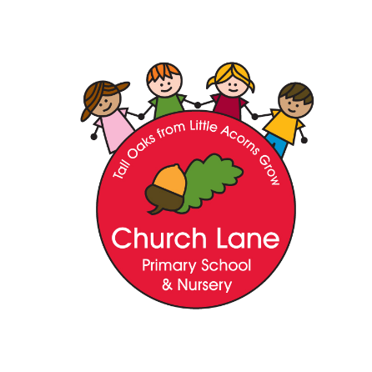

Church Lane Primary School and Nursery

History Policy

“That men do not learn very much from the lessons of history is the most important of all the lessons that history has to teach.”

― Aldous Huxley

Intent

At Church Lane, History forms an integral part of the curriculum. We believe the study of History inspires children’s curiosity, encourages them to ask critical questions, and helps them to have a better understanding of the society in which they live and that of the wider world. They will work as historians to answer enquiry questions and critically analysing sources of information. This will help provide the children with a sense of their own identity within a social, political, cultural and economic background.

We will ensure that our intention is met through:

- Developing an awareness of the past
- Encouraging children to explore different historical time periods
- Giving them the opportunity to experience local history
- Developing a wide yet appropriate vocabulary to understand the topics
- Encouraging critical thinking and the encouragement of evaluating and challenging their views and the views of others
- Developing their sense of enquiry
- Developing a child’s appreciation of the world around them and how it has been made
- Giving opportunities to develop a sense of chronology
- Developing the communication of ideas suitable to range of audiences
- Being motivated to enjoy and succeed in History
- Having a clear progression throughout years and key stages
- Enabling an excellent knowledge and understanding of people, events and contexts

History Curriculum

History is a foundation subject in the National Curriculum. The fundamental skills, knowledge and concepts of the subject are set out in National Curriculum 2014
We have used this national curriculum to create our own adapted curriculum for our children.

Our curriculum is laid out in the following way:
- EYFS study significant figures to do with the children’s lives and history as memories. In KS1 and 2 History knowledge is split into three areas in each year from years 1 to 5 and one thematic area in year 6 with key knowledge expected to be learnt in each area highlighted. (This is in the Progression of Knowledge Document). This knowledge is accompanied by procedural knowledge which are split into three sections: chronology, evidence and interpretations and perspectives. There are also questions that the children look at within each main area of history. (This information is in the Progression of Procedural Knowledge Document).These main areas are set out progressively throughout the school to ensure that the children’s knowledge is chronological and builds on what they already know.
- Each year group has a set area of History per term – this is shared with the children in a child friendly question, which encourages our children to engage with being historians whilst introducing them to high quality vocabulary. (This information is in the Yearly Map)
- Each question is then explored by the children through a number of lessons, which assist the children in gaining and building the knowledge and experience they need to achieve. (The in depth knowledge we will be teaching is contained in unit plans - these further breakdowns include the knowledge taught in the unit and the procedural knowledge taught across the year to ensure that our children gain both knowledge and experience of being historians.)

The progression of History knowledge is distributed as follows:

Underpinning all this is the school’s golden thread:
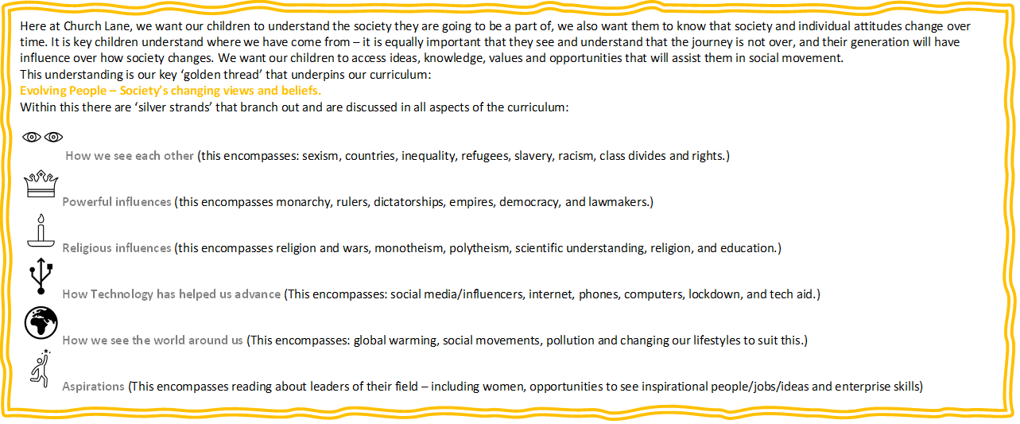

Principles of Teaching

- The History Curriculum has been developed to integrate national guidelines with class topics and themes.
- History is taught throughout Early Years Foundation Stage, Key Stage 1 and Key Stage 2.
- All pupils are encouraged to participate in and enjoy History lessons regardless of race, culture, gender, ability or physical limitations. A mutual respect and tolerance for all cultures will be promoted through the study of History.
- During History lessons pupils will be expected to work collaboratively in groups, as a whole class, in pairs and individually. Groups are chosen (by the teacher or pupils) appropriate to the task set. Children have the opportunity to work in groups of both mixed and same gender and ability.
- Pupils with special educational needs are supported within the classroom environment with strategies used that are appropriate to the child and their needs.
- Children who demonstrate a talent for History through understanding skills beyond their age will be given extra challenges through differentiated work, questioning and homework, and through extra-curricular activities and opportunities.
- Pupils’ achievements in their work is celebrated through the displaying of work. Children will also be praised in Celebration Assemblies.
- In EYFS the children are taught informally through questioning, discussion, continuous provision and engagement.
- Science lessons from Year 1 onwards will all have the same structure:
- A reminder of what Science involves as a subject area
- Feedback and recall of the prior lesson
- Related reading activities
- Vocabulary check – reviewing word knowledge and introducing new words.
- Discussion of the question and answering of the question (Through either research or discovery)

Role of the History Coordinator

  - Endeavour to promote a dynamic approach to the development of History ensuring that it has a high profile at the School.
  - To update and administer school History curriculum and oversee its implementation by other staff.
  - Keep up to date with developments in History through reading and course attendance etc.
  - Report back on courses attended.
  - Advise and support staff with History.
  - Regularly review and update the school policy statement and guidelines as required (outlining the aims, objectives involved in History).
  - Coordinate extra-curricular History activities as appropriate to staffing and pupil interest.

Assessment, Recording and Reporting

Teachers will assess children in History using the Itrack assessment system at the end of each academic year. Afl, is an important part of assessment and happens throughout the year.
Afl is a key part of a teacher’s assessment and pupil’s self and peer assessment.

Low-risks quizzing is done at the end of each unit to track children’s retention of knowledge and key concepts. This provides teachers with an opportunity to assess what children have understood and areas for further development.

Policy written: June 2024
Written by: Roberta Minucci
Review Date: June 2026

