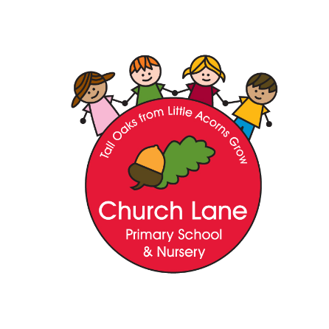

Church Lane Primary School and Nursery

Design and Technology Policy

It’s not just about having ideas, it’s about making ideas a reality.

Intent

Design and Technology at Church Lane allows children the opportunity to immerse themselves into the design process. Children learn how to design products, share their ideas, create products and then evaluate. Design and Technology covers a wide range of areas which give children an insight into how skills learnt during these sessions can be used in the future.

We will ensure that our intention is met through:

- Developing an understanding of creating for a purpose
- Encouraging children to explore different ways of sharing ideas.
- Giving opportunities to analyse design briefs.
- Developing a wider understanding of how Design and Technology fits into the world around us.
- Encouraging critical thinking and the encouragement of the evaluation process.
- Developing children’s sense of enquiry.
- Develop children’s ability and understanding of how to create products using the tools around them.

Design and Technology Curriculum Key stages 1 & 2

History is a foundation subject in the National Curriculum. The fundamental skills, knowledge and concepts of the subject are set out in National Curriculum 2014:
Key stage 1

Pupils will be taught to:

Design:
- design purposeful, functional, appealing products for themselves and other users based on design criteria.
- generate, develop, model, and communicate their ideas through talking, drawing, templates, mock-ups and, where appropriate, information and communication technology.
Make:
- select from and use a range of tools and equipment to perform practical tasks [for example, cutting, shaping, joining, and finishing]
- select from and use a wide range of materials and components, including construction materials, textiles and ingredients, according to their characteristics.
Evaluate:
- explore and evaluate a range of existing products.
- evaluate their ideas and products against design criteria.

Key stage 2

Pupils should continue to develop their understanding of the knowledge and skills taught in Key stage 1 and continue to build on the skills they have learnt.

Pupils will be taught to:

Design
- use research and develop design criteria to inform the design of innovative, functional, appealing products that are fit for purpose, aimed at particular individuals or groups.
- generate, develop, model and communicate their ideas through discussion, annotated sketches, cross-sectional and exploded diagrams, prototypes, pattern pieces and computer-aided design.

Make
- select from and use a wider range of tools and equipment to perform practical tasks [for example, cutting, shaping, joining and finishing], accurately.
- select from and use a wider range of materials and components, including construction materials, textiles and ingredients, according to their functional properties and aesthetic qualities.

Evaluate
- Investigate and analyse a range of existing products.
- evaluate their ideas and products against their own design criteria and consider the views of others to improve their work.
- understand how key events and individuals in design and technology have helped shape the world.

Design and Technology Curriculum Early Years Foundation Stage

Across EYFS Design and Technology enables children to make sense of the world around them and gain knowledge and understanding of their world. Children are encouraged to use all of their senses through:

open ended play- children explore a variety of materials including everyday objects, construction equipment and experimenting with tools such as scissors, hammers, hole punches and screwdrivers.

Using a variety of materials to make objects that are familiar to them and objects for function e.g. obstacles courses, large traps.

Exploring how to cut, make holes, mould, and join pieces of material together.

Engaging in our creative workshops that offer all of the above experiences and more.

Staff will encourage children make progress in Design and Technology by:

Encouraging all children to access the creative workshops.

Plan activities that challenge and enhance current interests.

Encouraging children to talk about what they have made and how they have made it.

Encouraging children to think of ways they could make their creation even better.

Challenging stereotypes e.g. making sure boys and girls use real life tools such as hammers and screwdrivers.

Providing provocations that are purposeful and meaningful e.g. a ball is stuck in the tree, how can we get it down? What could we create to help us with this?

Ensure children take part in activities that involve challenge and risk.

Principles of Teaching

- The Design and Technology Curriculum has been developed to integrate national guidelines and present children with opportunities to extend their cultural capital and take part in activities within their local community.
- History is taught throughout Early Years Foundation Stage, Key Stage 1 and Key Stage 2.
- Each class (Year 1 to Year 6) will take part in a blocked project at Christmas and another at the end of the summer term.
- All pupils are encouraged to participate in and enjoy Design and Technology lessons regardless of race, culture, gender, ability or physical limitations.
- During Design and Technology lessons pupils will be expected to work collaboratively in groups, as a whole class, in pairs and individually. Groups are chosen (by the teacher or pupils) appropriate to the task set. Children have the opportunity to work in groups of both mixed and same gender and ability.
- Pupils with special educational needs are supported within the classroom environment with strategies used that are appropriate to the child and their needs.
- Children who demonstrate a talent for Design and Technology through understanding skills beyond their age will be given extra challenges through differentiated work, questioning and homework, and through extra-curricular activities and opportunities.
- Pupils’ achievements in their work is celebrated through the displaying of work. Children will also be praised in Celebration Assemblies.

Role of the Design and Technology Coordinator

  - Endeavour to promote a dynamic approach to the development of Design and Technology ensuring that it has a high profile at the School.
  - To update and administer school Design and Technology curriculum and oversee its implementation by other staff.
  - Keep up to date with developments in Design and Technology through reading and course attendance etc.
  - Report back on courses attended.
  - Advise and support staff with Design and Technology.
  - Regularly review and update the school policy statement and guidelines as required (outlining the aims, objectives involved in Design and Technology).
  - Coordinate extra-curricular Design and Technology activities as appropriate to staffing and pupil interest.

Assessment, Recording and Reporting

Teachers will assess children in Design and Technology using the Itrack assessment system at the end of each academic year. Afl, is an important part of assessment and happens throughout the year.
Afl is a key part of a teacher’s assessment and pupil’s self and peer assessment.

Policy written: September 2023
Written by: Charlotte Massingham
Review Date: September 2025.

