

Church Lane Primary School and Nursery
Child Protection Policy/Procedure

2018/19

Contents
Introduction
Section 1 – Pupil information pages 1-5
  - Pupil Information
  - Transfer of files

Section 2 – Role and Responsibilities pages 5-9
2.1 Governing Body
2.2 Head teacher
2.3 Designated Safeguarding lead
2.4 All Staff and Volunteers

Section 3 - Child Protection Procedures pages 9-13
3.1 Definitions
3.2 Concerns that staff must immediately report
3.3 Responding to disclosure
3.4 Action by the Designated Safeguarding lead
3.5 Action following a child protection referral
3.6 Recording and monitoring

Appendices:
Appendix 1 Body Map Guidance
Appendix 2 What to do if you’re concerned about a child or young person in Lincolnshire
Appendix 3 Lincolnshire Safeguarding Children Board (LSCB)
Appendix 4 Referral flowchart (KCSIE 2018)

Introduction
These procedures should be read alongside the school’s Safeguarding Policy.

The aims of these procedures are:

- To clarify roles and responsibilities of everyone within our school in relation to safeguarding
- To have clear procedures that are followed when a child is identified as needing more than universal services can provide

The term “child “or “children” refers to anyone under the age of 18 years

Section 1 – Pupil Information
1.1 In order to keep children safe and provide appropriate care for them the school requires accurate and up to date information regarding:
- Names, contact details and relationship to the child of any persons with whom the child normally lives.
- names and contact details of all persons with parental responsibility (if different from above)
- emergency contact details (if different from above), ensuring that if the person(s) with parental responsibility is unable to collect this person, who could collect the child and keep them safe until either the person(s) with parental responsibility is available or a more suitable arrangement is made. The school encourages all parents and carers to provide more than one emergency contact, providing the school with additional options to make contact with a responsible adult when a child missing education is identified as a welfare and/or safeguarding concern
- details of any persons authorised to collect the child from school (if different from above)
- any relevant court orders in place including those which affect any person’s access to the child (e.g. Residence Order, Contact Order, Care Order, Injunctions etc.)
- if the child is or has been subject to a Child Protection Plan
- if the child is or has been subject to an Early Help Assessment (EHA) or Child In Need (CIN) processes.
- If the child is a Looked After Child (LAC)
- name and contact detail of G.P.
- any other factors which may impact on the safety and welfare of the child

The school will collate, store and agree access to this information, ensuring all information held electronically is stored securely with due regard to meeting data protection and safeguarding requirements.

This information will be stored primarily on Integris, with safeguarding information being stored on the schools CPOMS system. This information is accessible by teaching staff.
  - Transfer of files

When a child leaves the school, the pupil record, including child protection file which is separated from the main pupil record in a sealed envelope clearly marked as such, is transferred to the new school as soon as possible. This is usually done with a face-to face meeting unless the child moves out of area, if this is the case the file is transferred with an accompanying list of the files, e.g. pupil file, child protection file etc., by recorded delivery and signed for. The child protection file is clearly marked Child Protection, Confidential, for attention of Designated Safeguarding Lead and a receipt of this transfer will be retained.
The receiving school should sign a copy of the list to say that they have received the files and return that to the sending school for tracking and auditing purposes.
This information should be added to a record of transfer which the sending school keep until the child reaches their 25th birthday and must contain:
- Name & DOB of child
- Name & address of receiving school
- Date file(s) transferred with name and role of person who received it
- Date sending school received confirmation of receipt of files from receiving school
- Brief description of case at the time of transfer e.g. Child Protection Plan: Neglect.

In addition to the child protection file, the designated safeguarding lead should also consider if it would be appropriate to share any information with the new school or college in advance of a child leaving. For example, information that would allow the new school or college to continue supporting victims of abuse and have that support in place for when the child arrives.

The pupil record should not be weeded before transfer to the next school unless any records with a short retention period have been placed in the file. It is important to remember that the information which may seem unnecessary to the person weeding the file may be a vital piece of information required at a later stage.
Electronic documents that relate to the pupil file also need to be transferred, or, if duplicated in a master paper file, destroyed.
Sending schools do not need to keep copies of any records in the pupil record except if there is an ongoing legal action when the pupil leaves the school. Custody of and responsibility for the records passes to the school the pupil transfers to.
The school which the pupil attended until statutory school leaving age is responsible for retaining the pupil record until the pupil reaches the age of 25 years. This school retains a copy of the child’s chronology and any documents that the school created e.g. risk assessment in an archive until the child reaches the age of 25 years, the receipt of the transferred file is kept alongside this archive. Any archived files are stored securely in the same way as an active file.

If any records relating to child protection issues are placed on the pupil file, it should be in a sealed envelope and then retained for the same period of time as the pupil file. (DOB + 25 years)

Sources of further support:
- Data Protection Toolkit for Schools August 2018
https://assets.publishing.service.gov.uk/government/uploads/system/uploads/attachment_data/file/740740/Data_Protection_Toolkit_for_Schools_OpenBeta_V1.0.pdf
- Lincolnshire County Council Data Protection Advice Service
https://www.lincolnshire.gov.uk/edulincs/finance-and-professional-services/data-protection-advice-service-new-offer/-reduced-cost/132715.article
- Perspective Light/Safeguarding/Safeguarding Documents/IRMS Toolkit for schools + Data Protection Toolkit for Schools 2018

Section 2 - Roles and Responsibilities
2.1 Our Governing Body will ensure that:
- there is a named Safeguarding Governor
- the school has an effective Safeguarding policy and Child Protection policy/procedures in place that are in accordance with local authority guidance and locally agreed inter-agency procedures, and the policy is available publically via the school website or other means. The policy will be reviewed and updated on an annual basis
- the school has a staff behaviour policy or code of conduct and that this is provided to all staff and volunteers on induction. The policy includes acceptable use of technology, staff/pupil relationships and communications including the use of social media
- the school operates safer recruitment procedures and makes sure that all appropriate checks are carried out on staff and volunteers who work with children; and that any panel involved in the recruitment of staff has at least one member who has undertaken the Safer Recruitment Training.
- the school has procedures for dealing with allegations against staff and volunteers that comply with guidance from the local authority and locally agreed inter-agency procedures.
- online safety policy and procedures are in place and training and support is provided for staff and pupils to ensure that there is a good understanding of child protection issues related to electronic media.
- the school has appropriate electronic filtering and monitoring systems in place to ensure that children are safeguarded from potentially harmful and inappropriate online material; whilst recognising that “over blocking” should not lead to unreasonable restrictions as to what children can be taught.
- a senior member of the school’s leadership team is appointed to the role of DSL who will take lead responsibility for safeguarding and child protection.
- the school has one or more deputy DSL’s who are trained to the same standard as the lead DSL.
- children are taught about safeguarding, including online safety as part of providing a broad and balanced curriculum.
- staff including the Head teacher undertake appropriate safeguarding training which is updated annually
- they remedy, without delay, any deficiencies or weaknesses regarding child protection arrangements
- a governor is nominated to be responsible for liaising with the LA and /or partner agencies in the event of allegations of abuse being made against the head teacher
- where services or activities are provided on the school premises by another body, the body concerned has appropriate policies and procedures in place in regard to safeguarding children and child protection and liaises with the school on these matters where appropriate.
- they review their policies and procedures annually
- the school appoints an appropriately trained designated teacher with responsibility for “promoting the educational achievement of children who have left care through adoption, special guardianship or child arrangement orders or who were adopted from state care outside England and Wales” in addition to Looked After Children (LAC).

2.2 Our Head Teacher will ensure that:
- the policies and procedures adopted by the Governing Body or Proprietor are fully implemented, and followed by all staff;
- sufficient resources and time are allocated to enable the designated safeguarding lead and other staff to discharge their responsibilities including taking part in strategy discussions and other inter-agency meetings and contributing to the assessments of children.
- there are arrangements in place for Safeguarding Supervision for the Designated Safeguarding Lead and the deputy Designated Safeguarding Lead(s)
- all staff and volunteers feel able to raise concerns about poor or unsafe practice in regard to children, and such concerns are addressed sensitively and effectively in a timely manner in accordance with agreed whistle blowing policies and use of the LSCB Professional Resolution and Escalation Protocol
- the Designated Safeguarding Lead is supported in providing a contact for the school to provide a report and attend Initial Child Protection Case Conferences, Reviews and Looked After Children Reviews out of school term time when needed
- allegations regarding staff or any other adults in the school are referred to the Local Authority Designated Officer (LADO), as set out in the Managing Allegations procedure.
- individuals are referred to the Disclosure and Barring Service (cases where a person is dismissed or left due to risk/harm to a child). This is a legal duty placed upon the school.

2.3 Our Designated Safeguarding Lead (DSL) as stated in KCSIE (2018) will ensure that they:

Manage referrals
• refer cases of suspected abuse to the local authority children’s social care (Customer Service Centre)

• support staff who make referrals to Customer Service Centre

• seek advice from Prevent Team regarding radicalisation concerns & refer cases to the Channel programme when necessary

• support staff who make referrals to the Channel programme when advised by Prevent team

•support the Head to refer cases where a person is dismissed or left due to risk/harm to a child to the Disclosure and Barring Service as required

• refer cases to the Police where a crime may have been committed

Work with others
• liaise with the head teacher to inform them of issues especially ongoing enquiries under section 47 of the Children Act 1989 and police investigations

• as required, liaise with the “case manager” (as per Part four of KCSIE) and the designated officer (LADO) for child protection concerns (all cases which concern a staff member or volunteer)

• liaise with staff on matters of safety and safeguarding and when deciding whether to make a referral by liaising with relevant agencies. Act as a source of support, advice and expertise for staff.

Undertake training

The DSL (and any deputies) will undergo training to provide them with the knowledge and skills required to carry out the role. This training will be updated at least every two years. They will also undertake Prevent awareness training.

In addition to the formal training, their knowledge and skills will be refreshed at regular intervals, as required, but at least annually, to allow them to understand and keep up with any developments relevant to their role (this will be done by attending the termly DSL Safeguarding Briefings and by attending appropriate Lincolnshire Safeguarding Children Board inter-agency training and other relevant training and/or conference opportunities) so they:
• understand the assessment process for providing early help and intervention, for example through locally agreed common and shared assessment processes such as early help assessments

• have a working knowledge of how local authorities conduct a child protection case conference and a child protection review conference and be able to attend and contribute to these effectively when required to do so

• ensure each member of staff, especially new and part time staff has access to and understands the school’s or college’s child protection policy and procedures

• are alert to the specific needs of children in need, those with special educational needs and young carers

• are able to keep detailed, accurate, secure written records of concerns and referrals

• understand and support the school or college with regards to the requirements of the Prevent duty and are able to provide advice and support to staff on protecting children from the risk of radicalisation

• obtain access to resources and attend any relevant or refresher training courses

• encourage a culture of listening to children and taking account of their wishes and feelings, among all staff, in any measures the school or college may put in place to protect them.

Raise Awareness

• ensure the school or college’s child protection policies are known, understood and used appropriately

• ensure the school or college’s child protection policy is reviewed annually the procedures and implementation are updated and reviewed regularly and work with governing bodies or proprietors regarding this

• ensure the child protection policy is available publicly and parents are aware of the fact that referrals about suspected abuse or neglect may be made and the role of the school or college in this

• link with the Lincolnshire Safeguarding Children Board to make sure staff are aware of training opportunities and the latest local policies on safeguarding.

Availability
• during term time the designated safeguarding lead (or a deputy) will always be available for staff in the school or college to discuss any safeguarding concerns.

• there will also be a DSL or deputy available to be contacted out of hours/out of term for urgent enquiries such as an Initial Child Protection Case Conference.

Callum Clay (Headteacher) DSL

2.4 All staff and volunteers will:

- read and sign to say that they understand and will fully comply with the
school’s policies and procedures
- read and sign to say that they understand Part 1 of ‘Keeping Children Safe in
Education’ (2018)
- identify concerns as early as possible and provide help, to prevent concerns from escalating and identify children who may be in need of extra help or who are suffering or are likely to suffer significant harm
- attend annual whole school safeguarding training and other appropriate training identified
- provide a safe environment in which children can learn
- be aware that they may be asked to support a Social Worker to take decisions about individual children
- inform the designated safeguarding lead of any concerns about a child immediately
- inform the head of any concerns regarding an adult within school at the earliest opportunity
- inform the Chair of Governors of any concerns regarding the head at the earliest opportunity
- act on the concern and make the referral themselves if they feel the concern is not being taken seriously.

Section 3 – Child Protection Procedures
3.1
Definitions:
(‘Working Together’ 2018 and ‘Keeping Children Safe in Education’ 2018)

A child: any person under the age of 18 years.

Harm means ill-treatment or impairment of health and development, including, for example, impairment suffered from seeing or hearing the ill-treatment of another;

Development means physical, intellectual, emotional, social or behavioural development;

Health includes physical and mental health; maltreatment includes sexual abuse and other forms of ill-treatment which are not physical.

Abuse: a form of maltreatment of a child. Somebody may abuse or neglect a child by inflicting harm or by failing to act to prevent harm. Children may be abused in a family or in an institutional or community setting by those known to them or, more rarely, by others (e.g. via the internet). They may be abused by an adult or adults or another child or children.
Physical abuse: a form of abuse which may involve hitting, shaking, throwing, poisoning, burning or scalding, drowning, suffocating or otherwise causing physical harm to a child. Physical harm may also be caused when a parent or carer fabricates the symptoms of, or deliberately induces, illness in a child (Fabricated Induced Illness).
Emotional abuse: the persistent emotional maltreatment of a child such as to cause severe and adverse effects on the child’s emotional development. It may involve conveying to a child that they are worthless or unloved, inadequate, or valued only insofar as they meet the needs of another person. It may include not giving the child opportunities to express their views, deliberately silencing them or ‘making fun’ of what they say or how they communicate. It may feature age or developmentally inappropriate expectations being imposed on children. These may include interactions that are beyond a child’s developmental capability as well as overprotection and limitation of exploration and learning, or preventing the child participating in normal social interaction. It may involve seeing or hearing the ill-treatment of another. It may involve serious bullying (including cyberbullying), causing children frequently to feel frightened or in danger, or the exploitation or corruption of children. Some level of emotional abuse is involved in all types of maltreatment of a child, although it may occur alone.
Sexual abuse: involves forcing or enticing a child or young person to take part in sexual activities, not necessarily involving a high level of violence, whether or not the child is aware of what is happening. The activities may involve physical contact, including assault by penetration (for example rape or oral sex) or non-penetrative acts such as masturbation, kissing, rubbing and touching outside of clothing. They may also include non-contact activities, such as involving children in looking at, or in the production of, sexual images, watching sexual activities, encouraging children to behave in sexually inappropriate ways, or grooming a child in preparation for abuse (including via the internet). Sexual abuse is not solely perpetrated by adult males. Women can also commit acts of sexual abuse, as can other children.
Neglect: the persistent failure to meet a child’s basic physical and/or psychological needs, likely to result in the serious impairment of the child’s health or development. Neglect may occur during pregnancy as a result of maternal substance abuse. Once a child is born, neglect may involve a parent or carer failing to: provide adequate food, clothing and shelter (including exclusion from home or abandonment); protect a child from physical and emotional harm or danger; ensure adequate supervision (including the use of inadequate care-givers); or ensure access to appropriate medical care or treatment. It may also include neglect of, or unresponsiveness to, a child’s basic emotional needs.

All staff follow the schools Child Protection Procedures which are consistent with ‘Working Together to Safeguard Children 2018’ and the Lincolnshire Safeguarding Children Board guidance.

Teachers and other adults in school are well placed to observe any physical, emotional or behavioural signs which indicate that a child may be suffering significant harm. The relationships between staff, pupils, parents and the public which foster respect, confidence and trust can lead to disclosures of abuse, and/or school staff being alerted to concerns. Definitions of the four main types of abuse are within the Safeguarding Policy.
All staff will also have an awareness of specific safeguarding issues as referred to in the Safeguarding Policy, in particular Domestic Abuse, Child Sexual Exploitation (CSE), Radicalisation and the Prevent Duty, Female Genital Mutilation (FGM), Attendance and Children Missing from Education (CME). Staff will also be aware that behaviours linked to drug taking, alcohol abuse, truanting and sexting put children in danger.
All staff will also be aware that safeguarding issues can manifest themselves via peer on peer abuse. This is most likely to include, but not limited to: bullying (including cyber bullying), gender based violence/sexual assaults and sexting. Staff are clear as to the school or college’s policy and procedures with regards to peer on peer abuse.
It is not the responsibility of the school staff to investigate welfare concerns or determine the truth of any disclosure or allegation. All members of staff however, have a duty to recognise concerns and maintain an open mind. Accordingly all concerns regarding the welfare of pupils will be recorded and discussed with the designated safeguarding lead (or the deputy DSL in the absence of the DSL) prior to any discussion with parents.
If children are placed in any form of Alternative Provision for any part of their school day, this school will seek reassurance that the same child protection procedures will be followed and that any concerns will likewise be reported to our Designated Safeguarding Lead and their counterpart within the Alternative Provision.

3.2 Concerns that staff must act on immediately and report:
- any suspicion that a child is injured, marked, or bruised in a way which is not readily attributable to the normal knocks or scrapes received in play
- any explanation given which appears inconsistent or suspicious
- any behaviours which give rise to suspicions that a child may have suffered harm (e.g. worrying drawings or play)
- any concerns that a child may be suffering from inadequate care, ill treatment, or emotional maltreatment
- any concerns that a child is presenting signs or symptoms of abuse or neglect
- any significant changes in a child’s presentation, including non-attendance
- any hint or disclosure of abuse from any person
- any concerns regarding person(s) who may pose a risk to children (e.g. living in a household with children present)
- any potential indicators of CSE
- any potential indicators of FGM
- any potential indicators of Radicalisation
- any potential indicators of living in a household with Domestic Abuse

3.3 Responding to disclosure
Staff will not investigate but will, wherever possible, elicit enough information to pass on to the designated safeguarding lead in order that s/he can make an informed decision of what to do next.
The Designated Safeguarding Lead will ensure that the child’s wishes and feelings are taken into account when determining what action to take and what services to provide. Child Protection processes will operate with the best interests of the child at their core.
Staff will:
- listen to and take seriously any disclosure or information that a child may be at risk of harm
- try to ensure that the person disclosing does not have to speak to another member of school staff
- clarify the information
- Try to keep questions to a minimum and of an ‘open’ nature e.g. using TED technique – ‘Tell me, Explain to me, Describe to me….’
- try not to show signs of shock, horror or surprise
- not express feelings or judgements regarding any person alleged to have harmed the child
- explain sensitively to the person that they have a responsibility to refer the information to the designated safeguarding lead, children need to know that staff may not be able to uphold confidentiality where they are concerns about their safety or someone else’s
- reassure and support the person as far as possible
- explain that only those who ‘need to know’ will be told
- explain what will happen next and who will be involved as appropriate
- record details including date, what the child has said, in the child’s words on a ‘Record of Concern’/Cause for Concern’ form and pass to DSL or on electronic system e.g. CPOMS and record any visible signs, injuries or bruises on a Body Map
- record the context and content of their involvement, and will distinguish between fact, opinion and hearsay

3.4 Action by the Designated Safeguarding Lead (or deputy DSL in their absence)
Following any information raising concern, the designated safeguarding lead will consider:
- any urgent medical needs of the child
- whether the child is subject to a child protection plan
- discussing the matter with other agencies involved with the family
- consulting with appropriate persons e.g. Duty and Advice Team
- the child‘s wishes

Then decide:
- to talk to parents, unless to do so may place a child at risk of significant harm, impede any police investigation and/or place the member of staff or others at risk
- whether to make a child protection referral to Children’s Social Care-Duty and Advice Team because a child is suffering or is likely to suffer significant harm and if this needs to be undertaken immediately
OR
- not to make a referral at this stage
- if further monitoring is necessary
- if it would be appropriate to undertake an assessment (e.g. Early Help Assessment - EHA) and/or make a referral to Children’s Social Care- Customer Service Centre.

All information and actions taken, including the reasons for any decisions made, will be fully documented and the process depicted in the flowchart in Appendix 3 will be followed. All referrals to Customer Service Centre will be followed up in writing and these referrals will always be kept on file irrespective of the outcome.

3.5 Action following a child protection referral
The designated safeguarding lead or other appropriate member of staff will:
- make regular contact with the social worker involved to stay informed
- wherever possible, contribute to the strategy discussion
- provide a report for, attend and contribute to any subsequent child protection conference
- if the child or children are made the subject of a child protection plan, contribute to the child protection plan and attend core group meetings and review conferences
- where possible, share all reports with parents prior to meetings
- Where in disagreement with a decision and concerns still remain with the child firstly:
- Talk in the first instance to the DSL
- Check the referral included all the relevant information and clearly documented the concerns about the child
- Finally follow the professional resolution and escalation protocol shown on the LCSB website.
- where a child subject to a child protection plan moves from the school or goes missing, immediately inform Children’s Social Care- Customer Service Centre

3.6 Recording and monitoring
Accurate records will be made as soon as practicable and will clearly distinguish between observation, fact, opinion and hypothesis. All records will state who is providing the information, the date and time, information will be recorded in the child’s words where possible and a note made of the location and description of any injuries seen, if this is a paper record than this should be signed. As a school we will use the CPOMS system to record any information. Photographs of injuries must not be taken.
The DSL ensures that the method for other members of staff or volunteers passing on concerns or information is always adhered to as consistency is paramount in ensuring that nothing gets missed. All record of concerns are followed up and clearly show what action is being taken as a result of the concern and the outcomes of this action.
All documents will be retained in a ‘Child Protection file’, separate from the child’s school file. This will be locked away and only accessible to the head teacher and the DSL if a paper file. If an electronic file e.g. using CPOMS (Child Protection Online Management System), it will be stored securely with appropriate levels of limited access. See section 1.2.for details about record transfer & retention.

Body Map Guidance
Appendix 1 Body Map Guidance
Body Maps should be used to document and illustrate visible signs of harm and physical injuries.
Always use a black pen (never a pencil) and do not use correction fluid or any other eraser.
Do not remove clothing for the purpose of the examination unless the injury site is freely available because of treatment.
*At no time should an individual teacher/member of staff or school take photographic evidence of any injuries or marks to a child’s person, the body map below should be used. Any concerns should be reported and recorded without delay to Customer Service Centre or the child’s social worker if already an open case to social care.
When you notice an injury to a child, try to record the following information in respect of each mark identified e.g. red areas, swelling, bruising, cuts, lacerations and wounds, scalds and burns:
- Exact site of injury on the body, e.g. upper outer arm/left cheek.
- Size of injury - in appropriate centimetres or inches.
- Approximate shape of injury, e.g. round/square or straight line.
- Colour of injury - if more than one colour, say so.
- Is the skin broken?
- Is there any swelling at the site of the injury, or elsewhere?
- Is there a scab/any blistering/any bleeding?
- Is the injury clean or is there grit/fluff etc.?
- Is mobility restricted as a result of the injury?
- Does the site of the injury feel hot?
- Does the child feel hot?
- Does the child feel pain?
- Has the child’s body shape changed/are they holding themselves differently?

Importantly the date and time of the recording must be stated as well as the name and designation of the person making the record. Add any further comments as required.
Ensure First Aid is provided where required and then recorded appropriately.
A copy of the body map should be kept on the child’s concern/confidential file.

Meeting the needs of children and families in Lincolnshire 2018 is Lincolnshire's safeguarding model based on Signs of Safety.
Appendix 2 Statutory Interventions

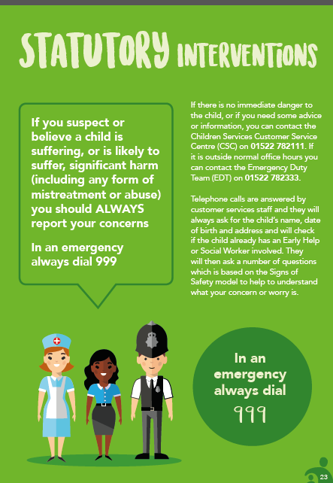


Appendix 3 Lincolnshire Safeguarding Children Board
Lincolnshire Safeguarding Children Board:
- Promotes safeguarding awareness
- Produces inter-agency policies, procedures and protocols
- Monitors and evaluates the effectiveness of local safeguarding services
- Provides core inter-agency safeguarding training
- Reviews child deaths
- Undertakes serious case reviews and shares key messages
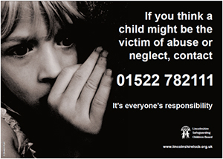

Safeguarding is everyone’s
responsibility

Customer Service Centre
Tel: 01522 782111

www.lincolnshire.gov.uk/lscb
Safeguarding Contacts
Appendix 4 Safeguarding Contacts

Advice on any aspect of Child Protection and Safeguarding may be sought from the Safeguarding Team;

Designated Safeguarding Lead (DSL)

Deputy Designated Safeguarding Lead(s)

Our local contact numbers are:

Safeguarding of children concerns (Children living in Lincolnshire) | 01522 782111  Lincolnshire's Children's Services Customer Service Centre for reporting concerns and Early Help Team for Advice  Emergency Duty Team  01522 782333 (6pm-8am + weekends and Bank Holidays)
Safeguarding of children concerns (Children living in other Authorities) | Please add in relevant authority contact numbers if applicable as concerns for children need to be reported to the local authority in which the child resides (or state n/a)
Allegations against /concerns about adult(s) working with children  Staff must report concerns to the head teacher or in the event of concerns about the head teacher concerns must be reported to the Chair of Governors. | Lincolnshire Local Authority Designated Officers (LADO)  Rachel Powis & Jemma Parkinson  01522 554674  LADO@lincolnshire.gcsx.gov.uk  The Head/Chair must contact LADO to discuss concerns & course of action.
Police (Emergency)  Police (Non-Emergency) | 999  101
LCC Safeguarding in Schools for advice around safeguarding policy, audits, training etc. | Ruth Fox – Safeguarding & Education Welfare Supervisor  safeguardinginschools@lincolnshire.gov.uk  Tel: 01522 554695

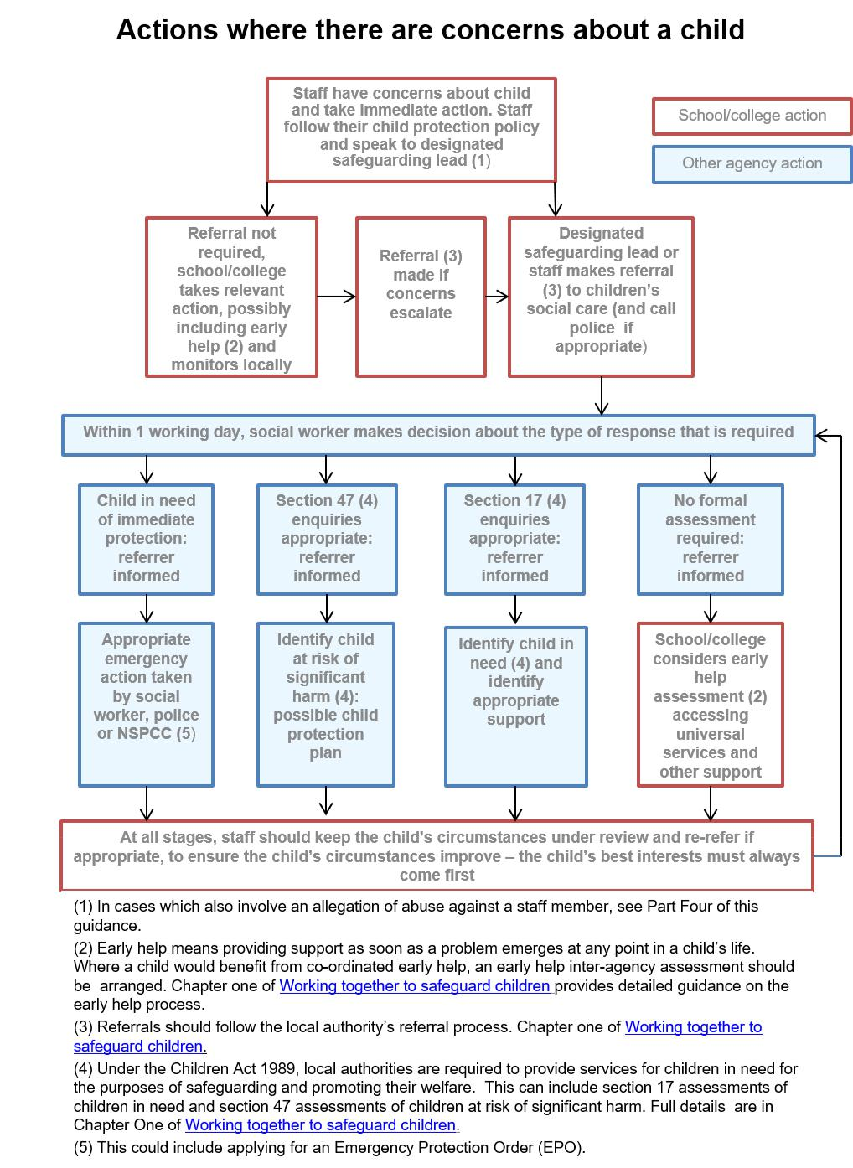
Appendix 5 Referral Flowchart from Keeping Children Safe in Education 2018 (KCSIE)

