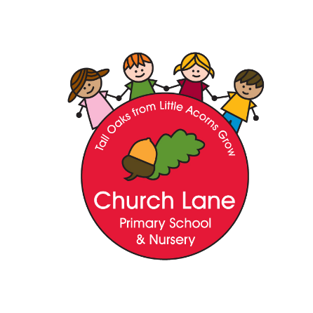

Church Lane Primary School and Nursery

History Policy

“Ideas shape the course of history’ – John Maynard Keynes

‘There is history in all men’s lives’ – William Shakespeare

‘We are not the makers of history. We are made by history’ – Martin Luther King Jr.

Intent

At Church Lane, History forms an integral part of the curriculum. We believe the study of History inspires children’s curiosity, encourages them to ask critical questions, helping them to have a better understanding of the society in which they live and that of the wider world. They will work as historians to answer enquiry questions, critically analysing sources of information, helping provide the children with a sense of their own identity within a social, political, cultural and economic background.

We will ensure that our intention is met through:

- Developing an awareness of the past
- Encouraging children to explore different historical time periods
- Giving them the opportunity to experience local history
- Developing a wide yet appropriate vocabulary to understand the topics
- Encouraging critical thinking and the encouragement of evaluating and challenging their views and the views of others
- Developing their sense of enquiry
- Developing a child’s appreciation of the world around them and how it has been made
- Giving opportunities to develop a sense of chronology
- Developing the communication of ideas suitable to range of audiences
- Being motivated to enjoy and succeed in History
- Having a clear progression throughout years and key stages
- Enabling an excellent knowledge and understanding of people, events and contexts

History Curriculum Key stages 1 & 2

History is a foundation subject in the National Curriculum. The fundamental skills, knowledge and concepts of the subject are set out in National Curriculum 2014:
Key stage 1

Pupils should be taught about:
- Changes within living memory
- Events beyond living memory that are significant nationally or globally
- The lives of significant individuals in the past that have contributed to national and international achievements
- Significant historical events, people and places in their own locality.

Key stage 2

Pupils should continue to develop a chronologically secure knowledge and understanding of British, local and world history. They should note connections, contrasts and trends over time as well as develop the appropriate use of historical terms, They should address and form their own historically valid questions about change, cause, similarity and difference as well as significance.

Pupils should be taught about:
- Changes in Britain from the Stone Age to Iron Age
- The Roman Empire and its impact on Britain
- British settlements by Anglo-Saxons and Scots
- The Viking and Anglo-Saxon struggle for the Kingdom of England
- A local history study
- The achievements of the earliest civilizations (Ancient Sumer, The Indus Valley, The Shang Dynasty of Ancient China and Ancient Egypt)
- Ancient Greece
- A study of an aspect or theme in British history that extends pupils’ chronological knowledge beyond 1066
- A non-European study that provides contrasts with British history (Mayan Civilization)

History Curriculum Early Years Foundation Stage

The Early Years Foundation Stage curriculum is based on seven areas of learning aiming to promote all aspects of a child’s development. History comes under the ‘Understanding the World’ area of learning. The EYFS curriculum starts from birth and children progress though each stage of development aiming to achieve the Early Learning Goals by the end of their Reception year. The assessment for the EYFS is formative. The Early Learning Goals relating to History are:
People and Communities
Children join in with routines and take part in celebrating special times. They can talk about past and present events in their own lives and the lives of their families. They can understand that everyone is different and that people don’t always like the same things as them. They understand that there are similarities and differences between themselves and others by exploring traditions.

The World
Children know about the similarities and differences in relation to places, objects, materials and living things. They can make observations and explain why some things occur and the changes that happen. They can describe how things change and notice similarities and differences about world around them.
During the Early Years Foundation Stage, begin to understand their place in the class, school, community and the wider world. They can begin to make connections to the ways in which things change and start to notice key concepts like continuity.

Principles of Teaching

- The History Curriculum has been developed to integrate national guidelines with class topics and themes (cross-curricular links)
- History is taught throughout Early Years Foundation Stage, Key Stage 1 and Key Stage 2.
- Each class (Year 1 to Year 6) will deliver at least one hour of History explicitly every fortnight. However, it is linked with a range of core and foundations subjects meaning that History can be taught more frequently.
- All pupils are encouraged to participate in and enjoy History lessons regardless of race, culture, gender, ability or physical limitations. A mutual respect and tolerance for all cultures will be promoted through the study of History.
- During History lessons pupils will be expected to work collaboratively in groups, as a whole class, in pairs and individually. Groups are chosen (by the teacher or pupils) appropriate to the task set. Children have the opportunity to work in groups of both mixed and same gender and ability.
- Pupils with special educational needs are supported within the classroom environment with strategies used that are appropriate to the child and their needs.
- Children who demonstrate a talent for History through understanding skills beyond their age will be given extra challenges through differentiated work, questioning and homework, and through extra-curricular activities and opportunities.
- Pupils’ achievements in their work is celebrated through the displaying of work. Children will also be praised in Celebration Assemblies.

Role of the History Coordinator

  - Endeavour to promote a dynamic approach to the development of History ensuring that it has a high profile at the School.
  - To update and administer school History curriculum and oversee its implementation by other staff.
  - Keep up to date with developments in History through reading and course attendance etc.
  - Report back on courses attended.
  - Advise and support staff with History.
  - Regularly review and update the school policy statement and guidelines as required (outlining the aims, objectives involved in History).
  - Coordinate extra-curricular History activities as appropriate to staffing and pupil interest.

Assessment, Recording and Reporting

Teachers will assess children in History using the Itrack assessment system at the end of each academic year. Afl, however, is also an important part of assessment and happens throughout the year.
Afl is a key part of a teacher’s assessment and pupil’s self and peer assessment.

Low-risks quizzing is done fortnightly to track children’s retention of knowledge and key concepts. In addition to this, mind maps are used to assess children’s knowledge prior to the unit and following it. This provides teachers with an opportunity to assess what children have understood and areas for further development.

Policy written: November 2019
Written by: Rachel Brand
Review Date: November 2021

