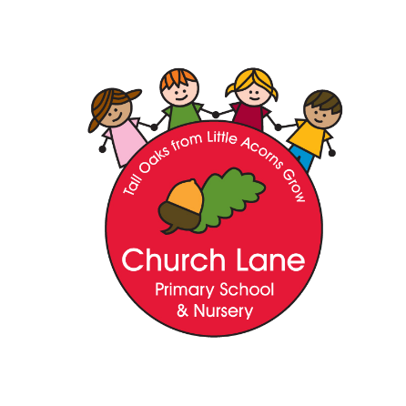

Church Lane Primary School and Nursery

Art and Design Policy

“Every child is an artist. The problem is how to remain an artist once we grow up” Pablo Picasso

“Creativity is contagious pass it on” Albert Einstein

Intent

At Church Lane, Art and Design is an important part of developing children’s ability to develop their individual creativity, express their ideas and understanding and to work individually and collaboratively with others. The Art curriculum provides children with opportunities to develop their skills of drawing, painting, printing, collage, textiles and 3D work. Children are given the opportunity to explore and evaluate different creative ideas. Children will be introduced to a range of works and develop knowledge of the styles and vocabulary used by famous artists. The skills they acquire are applied to their cross curricular topics allowing children to use their art kills, to reflect and explore topics in greater depth. In Art, children are asked to be reflective and evaluate their work, thinking about how they can make changes and keep improving

Our Art teaching provides an understanding of all the diverse art forms so that the children experience drawing, painting, collage, textiles, 3D designs, printmaking and digital media.

We will ensure that our intention is met through:

- Using experiences, ideas and other subjects across the curriculum as inspiration for artwork
- We will develop and share ideas using drawing, painting and sculpture
- We will explore a variety of techniques
- We will learn about a range of artists, architects and designers
- We will use our local community as inspiration for our work
- We will have a clear progression through the years and key stages

Art and Design Curriculum Key stages 1 & 2

Key stage 1
As children progress through Key Stage 1 they use their learned knowledge of tools and materials to explore and develop their ideas through drawing, painting, collage, textiles, digital media and printing.
In Key Stage 1 the children will be taught:
- To use a range of materials to design and make products
- To use drawing, painting and sculpture to develop and share ideas, experiences and imagination
- To develop a wide range of art and design techniques in using colour, pattern, texture, line, shape, form and space
- About the work of a range of artists, craft makers and designers and making links to their own work
- To use sketchbooks to record ideas/ designs

Key stage 2

Children’s creative development builds on the experiences provided by Key Stage 1. Knowledge and skills are extended and developed.

In Key Stage 2 the children will be taught:

- To improve their mastery of art and design techniques, including drawing, painting and sculpture using a range of materials
- About great artists and designers
- To use sketchbooks to record ideas/designs

Implementation:

- A knowledge organizer which outlines knowledge and key vocabulary
- Mind Maps
- Lessons that plan for progression and depth
- A low stakes quiz to support children to block learning and increase space in the working memory
- Challenge questions to support children to apply their learning
- Trips and visits to enhance the learning experience close links with the National Centre for Craft and Design
- Display will celebrate the pupil’s artwork

Impact

Our Art Curriculum is focused on skills and progression. We measure the impact through:
- Reflecting on standards achieved against the milestones and concepts
- Mind Maps before and after teaching
- Pupil discussions about their learning: thoughts, ideas and evaluations of work

Art and Design Curriculum Early Years Foundation Stage

The Early Years Foundation Stage curriculum is based on seven areas of learning aiming to promote all aspects of a child’s development. Art and Design comes under the areas of learning:
Expressive Art and Design: Exploring and using media and materials
Expressive Design: Being Imaginative

The EYFS curriculum starts from birth and children progress though each stage of development aiming to achieve the Early Learning Goals by the end of their Reception year. The assessment for the EYFS is formative. The Early Learning Goals relating to Art and Design are:

Exploring and using media and materials
Children sing songs, make music and dance and experiment with ways of changing them. They safely use and explore a variety of materials, tools and techniques, experimenting with colour, design, texture, form and function.

Being Imaginative
Children use what they have learnt about media and materials in original ways, thinking about uses and purposes. They represent their own ideas, thoughts and feelings through design and technology, art music, dance, role play and stories.

Assessment, Recording and Reporting

Teachers will assess children in Art and Design using the Itrack assessment system. Afl, however, is also an important part of assessment and happens throughout the year.
Afl is a key part of a teacher’s assessment and pupil’s self and peer assessment.

Policy written: September 2019
Written by: Anne Daynes
Review Date: September 2021

