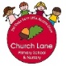Year N autumn educational programme 2020-2021

This is a flexible educational programme- it will be adapted to suit the needs of the cohort and will be guided by the children’s goals, interests and gaps in learning.

Autumn

Alongside our ‘in the moment’ planning we will provide the children with the following experiences to ignite learning, spark new interests and teach knowledge and skills.

The experiences and continuous provision enhancements provided will go hand-in-hand with their social and personal development.

Physical Development

Our indoor and outdoor environment will be set up to provide the children will all the skills to promote gross and fine motor skills.

This term we will focus on supporting **gross motor skills**- core strength, stability, balance and spatial awareness. The children will have daily access to the field where games and equipment will be provided to encourgae gross motor skills. The children will access the field at the start of their session to wake up their minds and bodies.

Move with Zip Active will also be used to promote each child’s physical development.

The children will develop their fine motor skills through their play.

Communication and Language

Every child will take part in a language assessment (Wellcomm). This will help identify any gaps in language development and will support our planning to close the gaps. Parents will be informed throughout and also given some activity ideas to help at home too.

Alongside sharing stories based on child’s interests we will focus on a ‘story a week.’ These stories will introduce each child to **rich vocabulary** where the children will explore the meaning in a playful way. The language will foster their understanding of our culturally, socially, technologically and ecologically diverse world. The children will be encouraged to talk about the seasonal change through their experiences and the books we read.

For example The Gruffalo and We’re Going on a Bear Hunt will introduce the children to words such as scaly, poisonous, feast, tusks, wavy, through, over, deep and squelch.

The children will explore a variety of poems from the Poetry Basket. The children will learn the words and act out the poems to bring them to life. The poems will include: Cup of Tea, Pointy Hat, Falling Apples and Breezy weather. Parents will be invited in to watch them perform or it will be recorded and uploaded to Tapestry.

Nursery rhymes will also play a big part of our daily routine and the children will take part in working memory games.

Key Texts to ignite and inspire learning

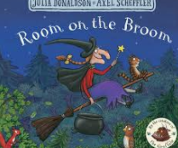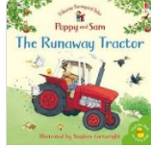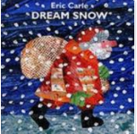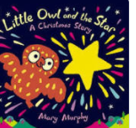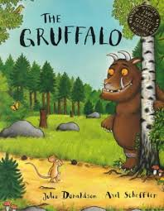

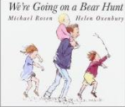 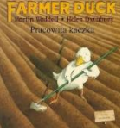 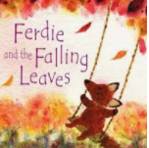 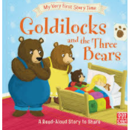

Personal, social and Emotional Development

The children will settle back into routine and be encouraged to establish secure relationships with their key worker and other staff members. The children will become familiar with the indoor and outdoor environments and expectations. Staff will begin building parent relationships using Tapestry and daily handovers.

The children will be supported to use the toilet and independence skills will be promoted throughout the daily routines. Key workers will work with parents to establish individual needs and work together to create a support plan (if needed).

Books to underpin this area will include: Owl Babies

Maths

Developing early Maths takes happens throughout the daily routines and equally as importantly through play. We will carefully look for opportunities where we will support the children to develop and deepen their understanding to 5.

Prepositional language will also be a focus by talking about where things belong in the room.

We will use snack time to support our mathematical development. The children will be asked questions such as who has more/who has less. They will compare quantities and practice careful counting. The children will pour their own drinks which will encourage the use of language such as, ‘full’, ‘empty’, ‘half full’ etc.

Our number rhymes that we will explore are: Five Little Pumpkins, One Potato, Two Potato, One Two Buckle my shoe, Three Blind Mice, Two Little Dickie Birds, Five Mince Pies

Literacy

Communication and Language are directly inter-linked with our Literacy programme.

In addition we will expose the children to Phase 1 Letters and Sounds Phonics. We will focus on listening and experimenting with environmental sounds and body percussion.

We will take part in celebrating National Nursery Rhyme Week.

Understanding of the World

We will read books such as Room on the Broom, Farmer Duck, We’re Going on a Bear Hunt, Ferdie and the Falling Leaves, Goldilocks and the Three Bears, The Gruffalo, Little Owl and the Star, The Runaway Tractor to talk and explore autumn, Christmas and Harvest.

We will also team up with Reception to celebrate Diwali.

We hope to explore Sleaford by visiting the market, River Slea and Tesco to widen our experiences and help us develop our understanding of our world and immediate surroundings.

Expressive Arts and Design

The children will learn new songs and rhymes throughout this term. They will develop their understanding that the art workshop can be freely accessed and they can use what they wish. They will begin their journey on exploring texture, colour and pattern. The children will be inspired to create their own Christmas cards and take part in Diwali crafts- making Diva lamps, Rangoli Patterns.