Church Lane Primary School

REMOTE LEARNING
STEP BY STEP GUIDE TO GSUITE
*PUPILS*

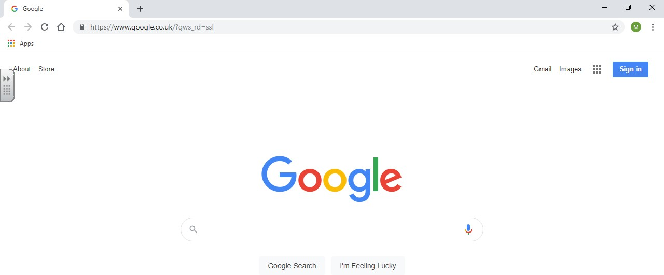
- Open up the internet browser using Google Chrome (It will not open using internet explorer, it must be using Google Chrome)

Once you are on this page, please make sure all other google/gmail accounts are completely logged out or it will keep redirecting you to the account that is logged on rather than the gsuite account.

Once on this page, in the search box type: https://classroom.google.com/u/0/h

Once you have typed the above address the ‘sign in’ box will appear. Sign in using your username and password.
- Your username looks like an email address, for example firstname.surname@wrangle.lincs.sch.uk
- Type in the password given by the teacher

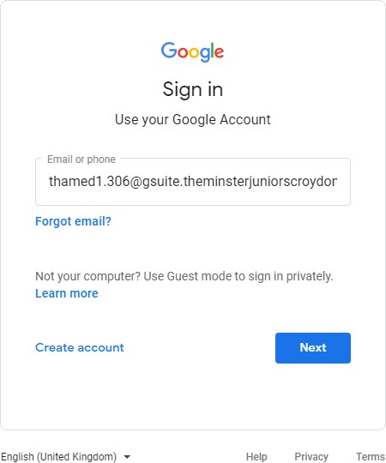
If you do not know your username or need your password reset, contact your class teacher on your class email address.
STEP 1

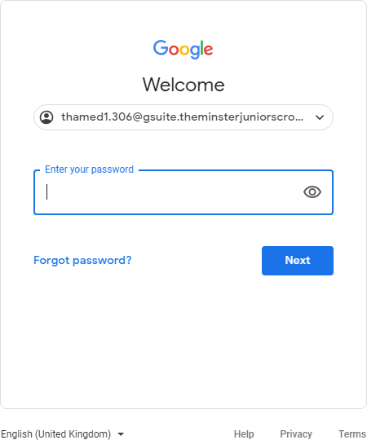
STEP 2

Once signed in, click the Matrix icon (9 dots) to get a list of apps available to you. This is located at the top right-hand side of the screen.

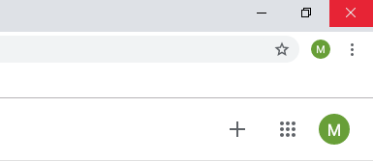
- The Matrix icon also gives you access to ALL of Google’s Apps i.e. Docs, Slides, Meet, etc.

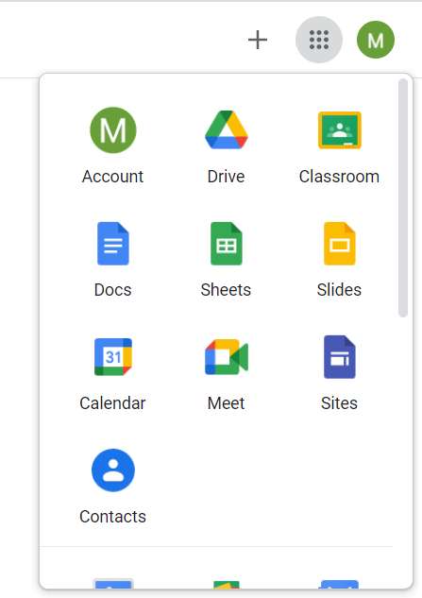
Choose the google classroom icon. Double click and open up classroom.

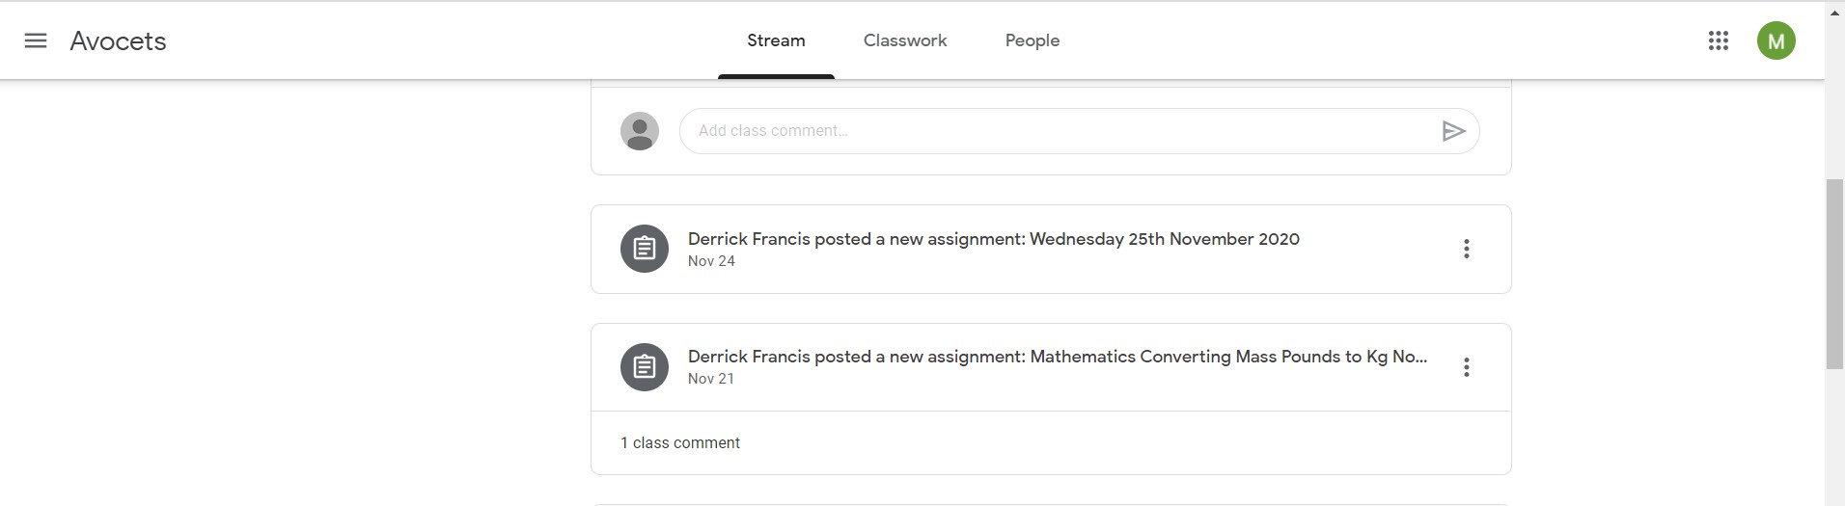
When you enter the class you will come to this Class homepage. It will always open on the Stream tab where you can see anything that has been posted by your teacher including assignments/classwork.

PLEASE DO NOT USE THE CLASS STREAM AS A “CHAT ROOM”.

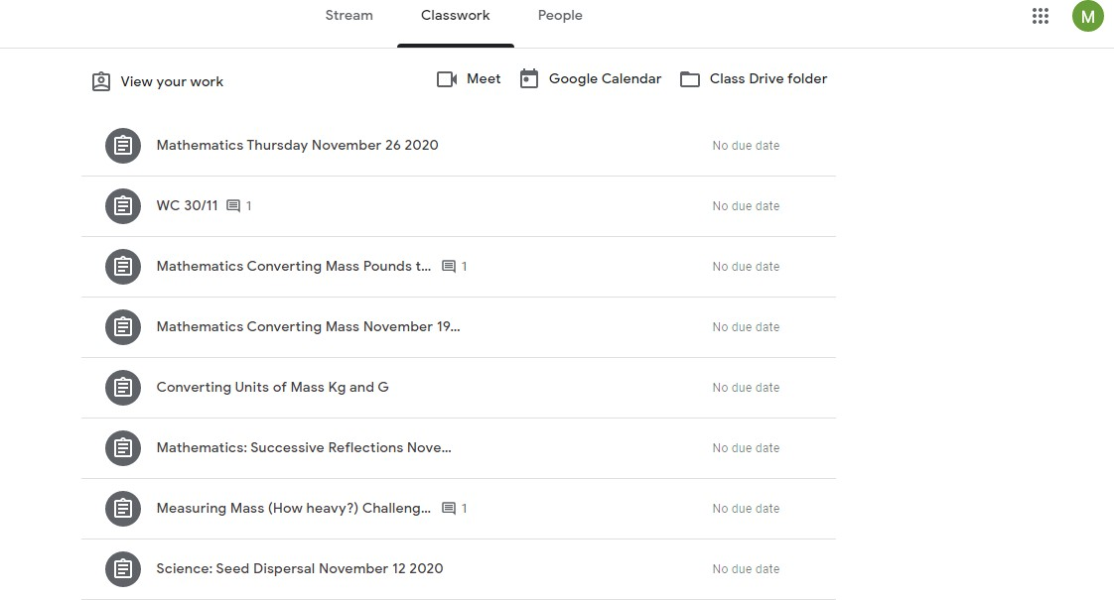
To find any assignments/classwork they will appear on the Stream tab.

They can also be found by clicking on the Classwork tab.

Click on the icon to view the classwork

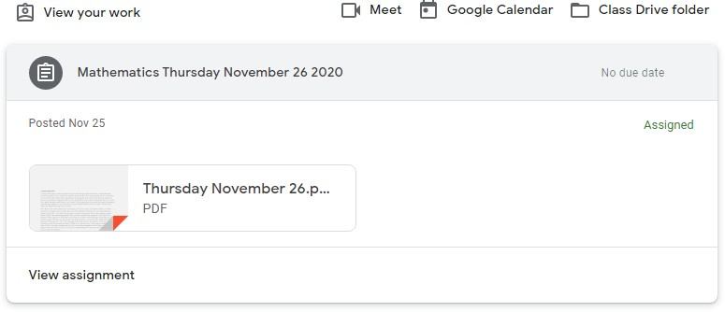
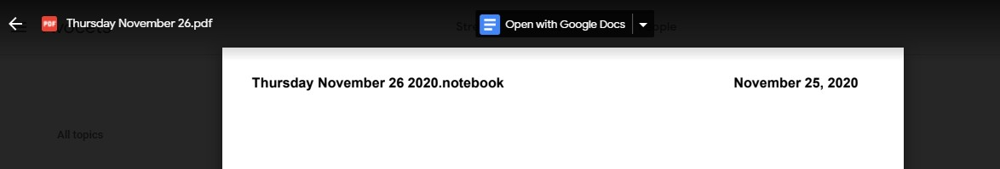
Then click on the lesson.

Click on ‘open with Google Docs’. This will allow you to type on the document.

Click on the lesson you would like to open

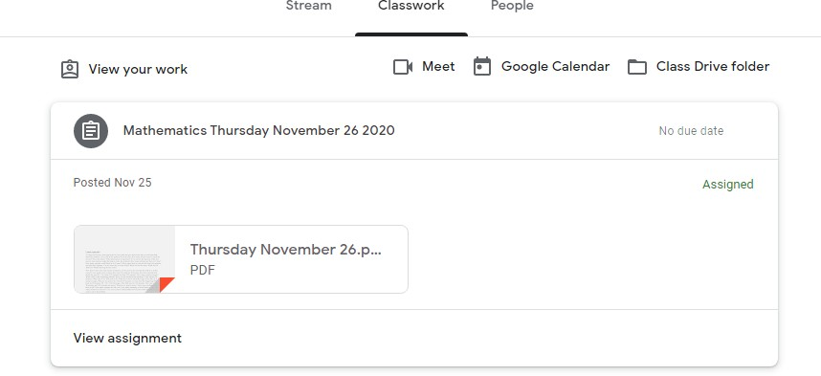
This time, click on ‘view assignment’.
This will open up the document for you to type on.

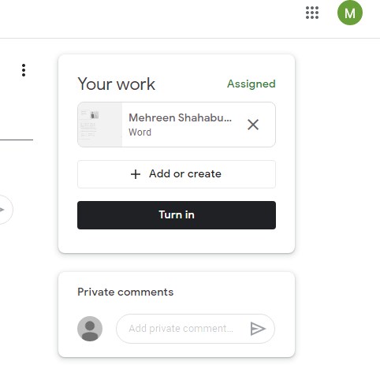
Once you have completed the work, send it to your teacher by clicking on ‘turn in’.

If you type in the ‘private comments’ box, this conversation will only be between you and your teacher and not shared with the whole class. This is where you can ask your teacher if you need extra help or are unsure of something for example.

Uploading Photos as assignment submissions
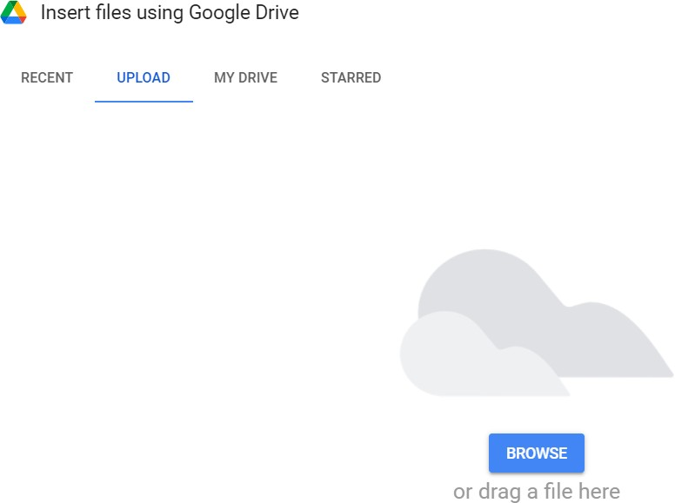
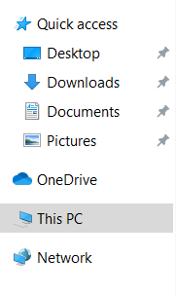
For lessons, such as Art, you may be asked to upload a photo of your work.
Click on Upload

Then click on Browse
Click on This PC and
select the image
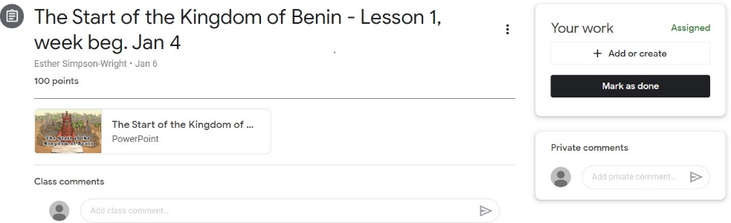

Click on Add or create then click on File

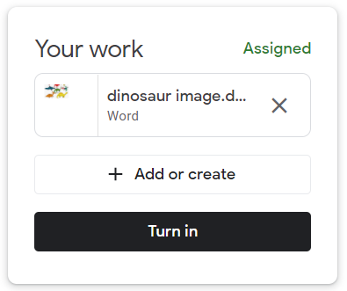
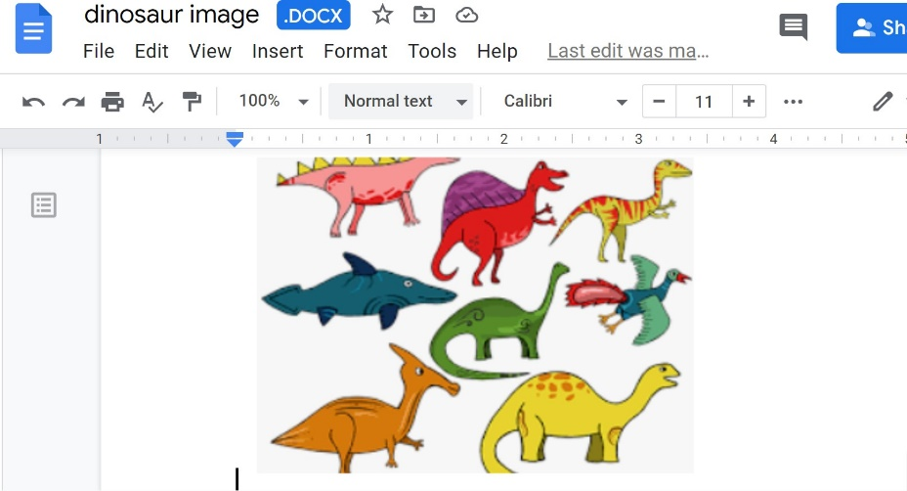
Dinosaur image is attached. Click turn in.

Click on the 9 dots

Click on the ‘Meet’ icon.

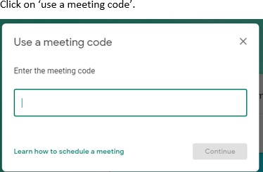
Type in the meeting code given by your class teacher.

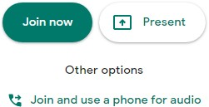
Click on ‘join now’.

Immediately when you are in your class meeting, you will be able to see yourself (if your camera is on). Click on the camera and the mic icons so both are off and it should look like the screen below.

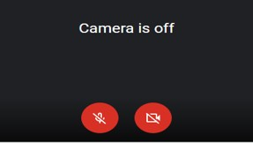
Microphone – so your teacher can
hear you
Camera – so your teacher can see you

When you click on the camera icon everyone present in the class will be able to see you. You can blur your background.

To do this (1) Click on the 3 little dots at the bottom of your screen.
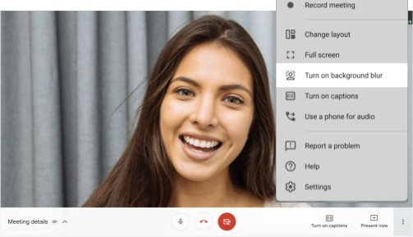
(2) Once the above options appear click on ‘Turn on background blur’.

Your teacher does not have the option to unmute you, so when your name is called out you must unmute yourself and respond. Do this by clicking on the ‘mic’ button below. Once you have unmuted yourself it should look like this

If you cannot use your mic during the lesson then please use the ‘chat’ icon available to communicate with your teacher. This icon is at the top of the
screen.

After you click on the ‘chat’ icon you should get this

Type your message and press ‘enter’. Your teacher will be able to see your questions and will either write a message back to you, or they will speak to you on the video.

If you are using an iPad to access Google Classroom or Google Meet, you will first need to download Google Chrome as your internet browser.
You will also need to download: Google Classroom, Google Meet, and Google docs. All of this software is free to download.
Ensure that your version of Google Meet is up to date by visiting the Play Store on Android devices or the App Store on iOS devices.
Alternatively, delete the app and then reinstall it from your mobile device's appropriate app store.

Accessing Google Meet:
Click on the Google Meet icon and sign in to your school account. Click on Join a Meeting and type in your class code.
You will then be able to join in the same way as the laptop/computer instructions detailed previously.

To access the chat function for asking questions during live lessons:

When on the google meet, tap once on the screen and the toolbar will appear at the bottom. It will look like this:

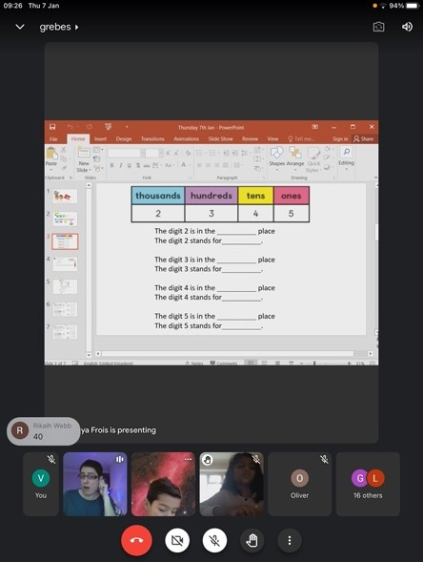
Click on the 3 dots

The option menu appears. Click on ‘In-call messages’ and the chat function will appear on your screen so you can ask your teacher any questions.
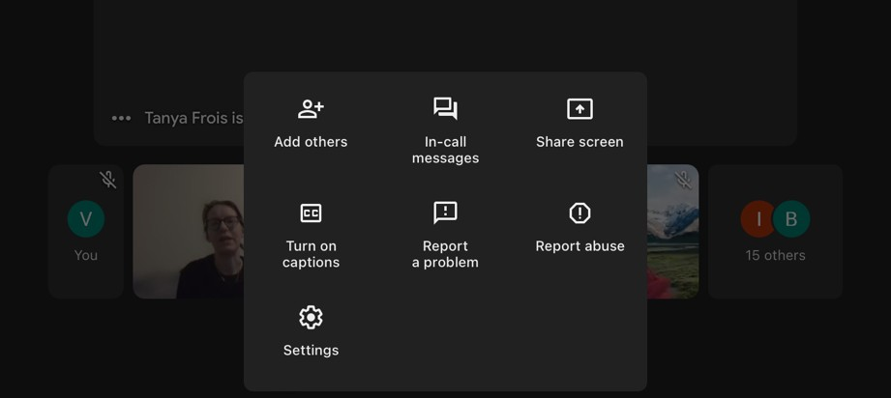

Accessing Google Classroom
You can access google classroom using Google Chrome as your internet browser in the same way you would on a laptop/computer. This is explained earlier on in this guide.

You can also access your Google Classroom using the Google Classroom app (if you have downloaded it onto your iPad) by opening the app and signing into your school account.

This is what your screen will look like once you’ve signed in.

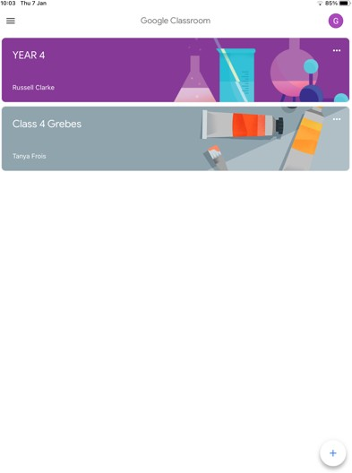
Your screen when you have signed in showing your classroom

Submitting classwork on an iPad
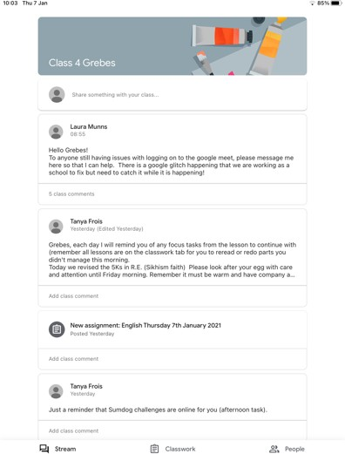
When you have signed in, click on your class and then at the bottom of the screen, select Classwork

What your classroom looks like once you’ve clicked on it
Click Classwork here

Select the lesson you want to complete by clicking on it

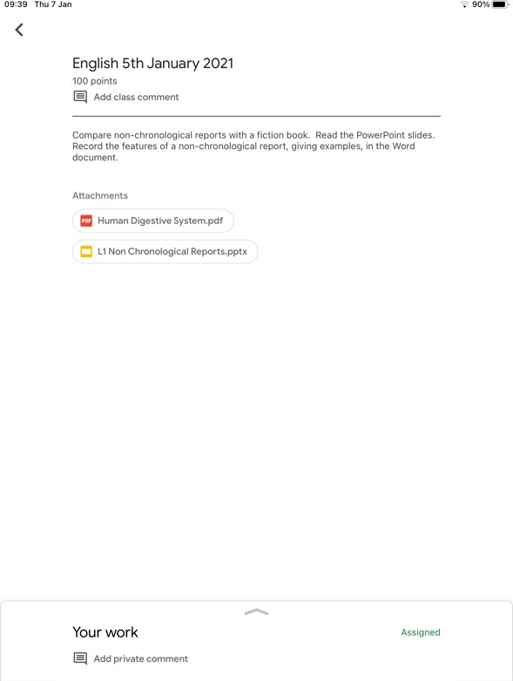
On the screen you will see the Task and any resources to help you complete it. At the bottom of the screen you will see ‘Your Work’ and an arrow pointing upwards. Click on this.

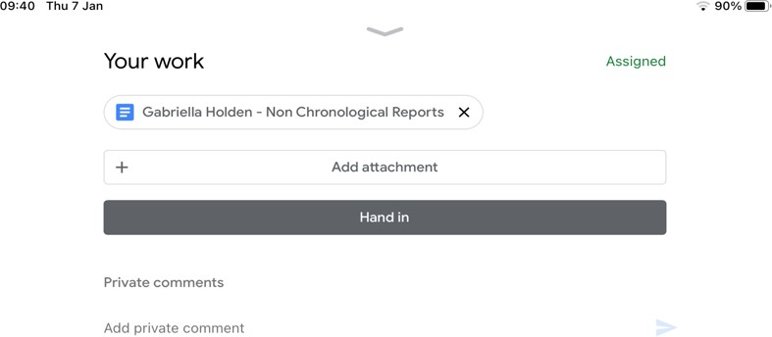
Select the document at the top

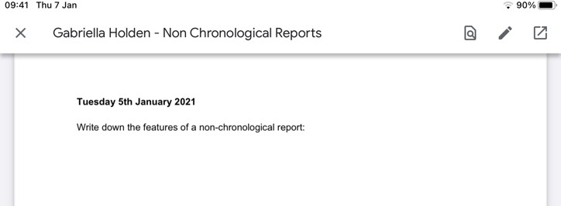
It will open up for you to read BUT you won’t to be able to type on it, we need to open it with Google docs. To do this, click on the box with an arrow in it – top
right hand corner

The document has now opened in google docs.
If you tap on the screen twice, you will be able to start typing on it

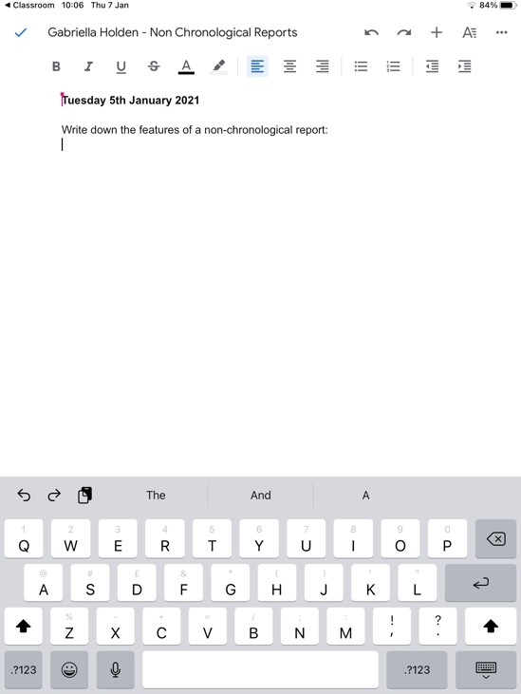

Once you have completed your assignment, click the back arrow to Classroom, above your name at the top. You work will have saved automatically.
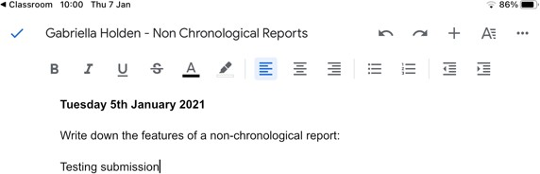

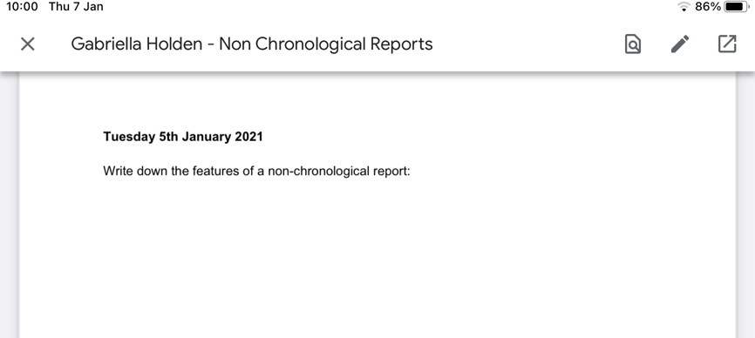
Your work will now show on the screen as a pdf and you won’t be able to type on it anymore. Click the X at the top left corner

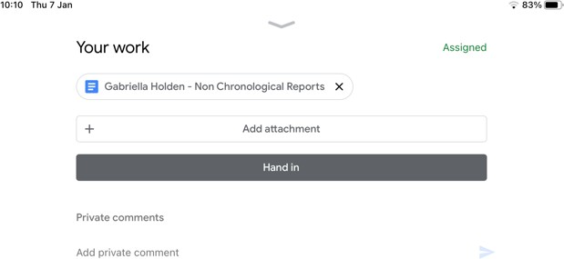
You will have returned to your work page. Here, remember to Click Hand In.

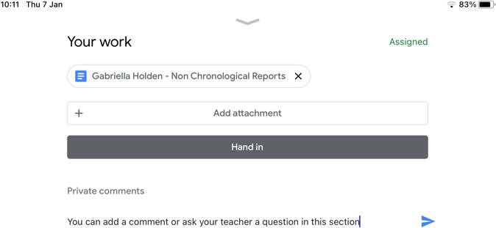
You can add a comment or question to your teacher if you wish. Then click the blue arrow to Send it to your teacher.

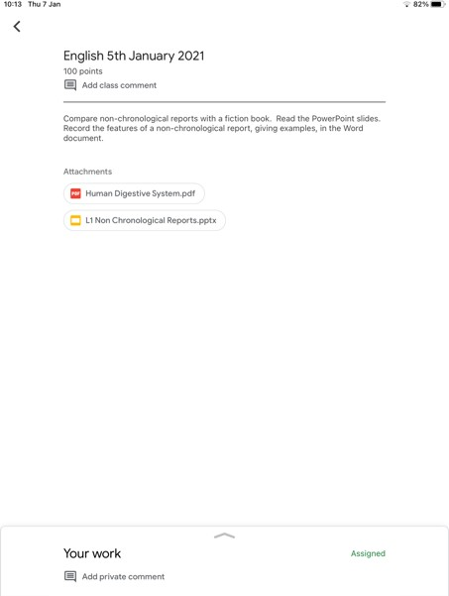
Once you have finished, click on the grey down arrow, and then the back arrow and
you will return to your Classroom

If you want to upload a photo

Click on Add attachment

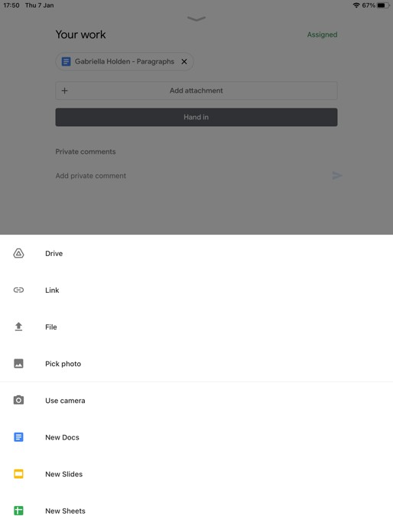
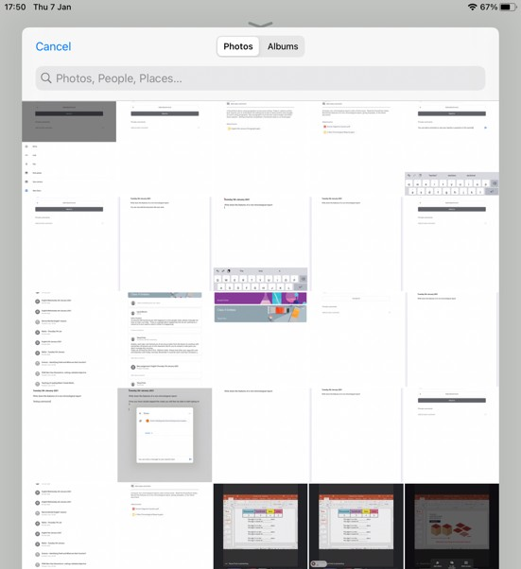
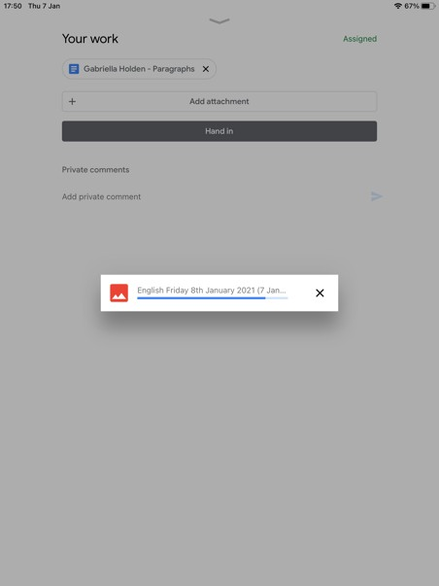
An option menu will appear. Click on File or pick photo
Select your photo
Then…
Click on Hand In

FAQ

Why can’t I open up Google Meet on my phone or ipad?
Ensure that your version of Google Meet is up to date by visiting the Play Store on Android devices or the App Store on iOS devices.
Alternatively, delete the app and then reinstall it from your mobile device's appropriate app store.

I have typed in my login details why can’t I open up Gsuite classroom?
You may be logged onto another Google or gmail account on your device. You must sign out of all the accounts running in the background. You will now be able to sign in using your school Gsuite logins.

My child cannot login to his/her account. An error appears on the screen. Why is that?
If you have typed your login details a few times and it is incorrect, you may now be locked out for security reasons. Contact the school and we will sort this for you.

I can’t connect to Gsuite today but it was working fine yesterday. What could be the issue?
This could be down to the internet connection or just a technical problem with Gsuite. Try restarting your device and log in again. If the problem still occurs please try again later. All work is uploaded in the google classroom so you can complete the lesson and worksheets at a later time once you are able to log in.

